**A STUDY OF ROLES AND FUNCTIONING OF STOCK-BROKING AGENCIES**

**Bachelor of Accounting and Finance**

**Semester VI**

**(2021-2022)**

**Submitted by**

**In Partial Fulfillment of the requirements**

**For the Award of Degree of**

**Bachelor of Accounting and Finance**

**By**

**(Priti Sanap)**

**(B/12.)**

**NIRMALA MEMORIAL FONDATION COLLEGE OF COMMERCE & SCIENCE**

**College Address: 90 Feet Rd, Kandivali, Thakur Complex, Kandivali East, Mumbai, Maharashtra 400101.**

**DECLARATION**

I, **Priti Sanap** the student of T.Y.B.A.F. Semester VI (2021- 2022) hereby declare that I have completed the project on **A study of roles and functioning of stock-broking agencies.**

The information submitted is true and original to the best of my knowledge.

_____________________

(Signature of Student)

Priti Sanap

B/12

NIRMALA MEMORIAL FONDATION COLLEGE OF COMMERCE & SCIENCE

College Address: 90 Feet Rd, Kandivali, Thakur Complex, Kandivali East, Mumbai, Maharashtra 400101.

**CERTIFICATE**

This is to certify that **Mr./Ms.Priti Sanap**, Roll no: **B/12** of Third Year **B.A.F.**, Semester VI (2021-2022) has successfully completed the project on **A study of roles and functioning of stock-broking agencies** under the guidance of **Prof. Shubham Kambli.**

Course Coordinator Principal

Project Guide/ Internal Examiner

External Examiner

**ACKNOWLEDGEMENT**

To list who all have helped me is difficult because they are so numerous and the depth is so enormous.

I would like to acknowledge the following as being idealistic channels and fresh dimensions in the completion of this project.

I take this opportunity to thank the University of Mumbai for giving me chance to do this project.

I would like to thank my Principal, **Ms. Swiddle D'Cunha** for providing the necessary facilities required for completion of this project.

I take this opportunity to thank our Coordinator, **Dr. Poonam Kakkad** for her moral support and guidance.

I would also like to express my sincere gratitude towards my project guide **Prof. Shubham Kambli** whose guidance and care made the project successful.

I would like to thank my College Library, for having provided various reference books and magazines related to my project.

Lastly, I would like to thank each and every person who directly or indirectly helped me in the completion of the project especially my Parents and Peers who supported me throughout my project.

**Table of Contents**

|  |  |  |
| --- | --- | --- |
| SR. No. | Contents | Page No. |
| 1. | INTRODUCTION | 1-35 |
|  |  |  |
| 2. | REVIEW OF LITERATURE | 36-58 |
|  |  |  |
| 3. | OBJECTIVES | 59 |
|  |  |  |
| 4. | RESEARCH AND METHODOLOGY | 60-63 |
|  |  |  |
| 5. | HYPOTHESIS | 64 |
|  |  |  |
| 6. | DATA ANALYSIS AND INTERPRETATION | 65-73 |
|  |  |  |
| 7. | CONCLUSION | 74 |
|  |  |  |
| 8. | SUGGETION | 75-76 |
|  |  |  |
| 9. | BIBLIOGRAPHY | 77 |
|  |  |  |
| 10. | APPENDIX | 78-80 |

**INTRODUCTION**

**Stock- Broker**

* **What Is a Stockbroker?**
* A stockbroker is a financial professional who executes orders in the market on behalf of clients. A stockbroker may also be known as a [registered representative](https://www.investopedia.com/terms/r/registeredrepresentative.asp) (RR) or an investment [advisor](https://www.investopedia.com/terms/a/advisor.asp).
* Most stockbrokers work for a brokerage firm and handle transactions for a number of individual and institutional customers. Stockbrokers are often paid on a commission basis although compensation methods vary by employer.
* Brokerage firms and broker-dealer companies are also sometimes referred to generically as stockbrokers. These include both[full-servicebrokers](https://www.investopedia.com/terms/f/fullservicebroker.asp) and[discount brokers](https://www.investopedia.com/terms/d/discountbroker.asp), who execute trades but do not offer individualized investing advice.  
    
  Most online brokers are discount brokers, at least at their basic levels of service, in which trades are executed for free or for a small set-price commission. Many online brokers now offer premium-level services with higher fees.
* -A stockbroker is a financial professional who buys and sells stocks at the direction of clients.  
    
  -Most buy and sell orders are now made through online discount brokers. This automated process reduces fees.  
    
  -Wealthy individuals and institutions continue to use full-service brokers, who offer advice and portfolio management services as well as completing transactions.

Stockbroking is a service which gives retail and institutional investors the opportunity to buy and sell equities.

Stockbrokers will trade shares both on exchange and over-the-counter, dependent on where they can find the best price and liquidity. Stock exchanges place strict regulations on who can trade shares directly on their books, which is why most individual investors hoping to trade shares will do so via a stockbroker.

Typically, a stockbroking firm will charge commission on the trades it makes on a client’s behalf, or a fee for retaining its services.

There are several different services a stockbroker can provide:

* **Execution-only** stockbrokers will complete orders on your behalf, but do not offer any advice
* **Advisory**stockbrokers will offer advice on where to trade, but only trade on orders submitted by you
* **Discretionary**stockbrokers will trade on your behalf, executing trades without your input

Stockbroking is **a service which gives retail and institutional investors the opportunity to buy and sell equities**. Stockbrokers will trade shares both on exchange and over-the-counter, dependent on where they can find the best price and liquidity.

A stockbroker is a middleman who has the authority to buy and sell stocks and securities in a stock exchange on the investor’s behalf

Stocks are traded through exchanges. However, an investor cannot directly trade in stock exchanges. To buy a stock or sell a stock through exchanges, you need an intermediary who will help you with the transaction. This middleman can be a person or a company who is authorised to buy and sell stocks and other securities on your behalf. Such a person or a company is known as a stockbroker. Stockbrokers are generally associated with a stockbroking firm, but they can also be an independent person. For providing this service, a stockbroker charges a commission or a fee.

When understanding stockbroker meaning, one should note that a stockbroker is performing a service for the investor. The role of a broker is to buy and sell [shares](https://www.angelone.in/knowledge-center/what-are-shares-and-types-of-shares) for a client. Stockbrokers also play another vital role; they provide information that helps an investor make correct investment decisions.

Let us look at the services a stockbroker traditionally provides to its clients in greater detail.

1. Stockbrokers give accurate advice on buying and selling stocks and other securities. Since they know the markets, they can advise a client on what stocks to buy and sell and when to buy or sell them.  They thoroughly research securities before making such recommendations
2. Stockbrokers buy and sell shares on behalf of their clients and handle the associated paperwork. They also act as a record keeper and keep records of all transactions, statements and so on
3. Stockbrokers manage the client’s investment portfolio and provide regular updates to their clients about their portfolios. They also answer investment questions that a client may have
4. Stockbrokers inform their client about any new investment opportunity in the stock market
5. Stockbroker also helps a client to make changes in investment strategies depending on the market conditions

**How are they regulated?**

Stockbrokers are governed under the Securities and Exchange Board of India Act 1992, Securities Contract Regulations Act, 1956, and also the Securities and Exchange Board of India (Stockbrokers and sub-brokers Regulations), 1992. Stockbrokers are also regulated under other rules, regulations and bylaws that SEBI may issue from time to time. Every stockbroker in India needs to be a member of stock exchanges and also requires to be registered with SEBI. Stockbrokers display their registration details on their websites and even on official documents. One can also visit the Sebi website and find details of registered stockbrokers.

## **What is a stockbroker?**

A stockbroker is a licensed professional with the authority to buy and sell stocks for other investors. Stockbrokers are regulated by the Securities and Exchange Commission (SEC) and are typically employed by a brokerage or a broker-dealer. Stockbrokers work on commission and usually receive a percentage of the trade’s value as their fee.

Stockbrokers fall into one of two categories: full-service brokers or discount brokers. The former offer a wide range of services, selling bonds, annuities, and insurance in addition to stocks. Merrill Lynch and [Morgan Stanley](https://www.bankrate.com/banking/reviews/) are the leading full-service brokerages. Discount brokers offer fewer services and engage in higher volumes of trades. Charles Schwab and Fidelity are considered discount brokerages.

The Financial Industry Regulator Authority (FINRA) licenses and oversees the industry. FINRA’s official designation for a licensed stockbroker is “registered representative.”

Stockbrokers must pass FINRA’s General Securities Representative Exam, commonly known as the Series 7 exam, in order to become registered representatives. The Series 7 gives them the authority to sell common and preferred stocks, bonds, call and put options, and other securities, excluding commodities, futures, life insurance or real estate. After passing the exam, they must be associated with a registered broker-dealer, also called a brokerage firm or a wirehouse.

Many states require stockbrokers to pass a Uniform Securities Agent exam, for which they will be granted a Series 63 license. The exam measures the candidates’ understanding of state securities acts, regulations, ethical practices and fiduciary obligations. Many stockbrokers choose to earn other licenses that give them the ability to offer more services to their clients, including:

* Series 3 license to sell commodity futures contracts.
* Series 6 license to sell mutual funds, variable annuities and unit investment trusts
* Series 65 license to offer financial or investment advice or work with managed-money accounts.
* Series 66 license, which combines the Series 63 and Series 65 licenses.

A good stockbroker can help you make sound investments. Check out [Bankrate’s investments calculators](https://www.bankrate.com/banking/money-market/rates/?ic_id=Content_CTA1) and see how you can improve your returns.

## **Stockbroker example**

Both full-service and discount brokers are employees of their firms. The most talented full-service brokers work on commission and can receive 40 percent of the fees paid by clients, with the remaining 60 percent going to the firm; lower-performing brokers receive more like 35 percent to 25 percent of the split. How much money clients have in their brokerage accounts can also dictate how much attention they get from stockbrokers. With full-service firms, the accounts with more money receive much more attention from brokers. Discount brokerages typically leave much of the investing decisions to their clients and merely execute the trades the client wants to make.

**What is broking agency?**

Manufacturers may use brokers and agents, who do not take title possession of the goods, in marketing their products. Brokers and agents typically perform only a few of the marketing flows, and their main function is **to ease buying and selling**—that is, to bring buyers and sellers together and negotiate between them.

**What is the purpose of brokerage firms?**

Brokerage companies exist to **help their clients match the other side of a trade**, bringing together buyers and sellers at the best price possible for each, and extracting a commission for their services.

**What do stockbrokers do?**

Stockbrokers serve as intermediaries between markets (e.g. exchanges) and the investing public. Brokers take order from customers and try to fill them at the best price possible. In return, they earn a fee known as a commission. Today, many stockbrokers have transitioned to financial advisors or planners as online brokerage platforms allow users to enter their own orders via the web or mobile app.

**What Is a Brokerage Firm?**

A brokerage firm is simply a place where investors and traders go for buying and selling stocks. The firm acts as a middleman between buyers and sellers, and provides a trading platform for everyone. It charges commission on these transactions. Every time an investor buys a stock, a transaction fee is charged.

Earlier, brokerage services were only available at physical offices of the firms. Nowadays, most transactions are carried out online via websites and apps. This has made trading much easier and more efficient, especially for day traders.

You can also start a share broking franchise business (a [**sub broker franchise**](https://www.indiainfoline.com/business-partners/how-does-sub-broker-franchise-work.html)) and give your company’s franchise to small and medium sub brokers.

**What Is a Sub Broker Franchise?**

A broking franchise gives franchise to smaller brokers in order to expand its clientele and make more money through the sub brokers. [**Sub brokers**](https://www.indiainfoline.com/business-partners/what-is-sub-broker.html) are like freelancers. They work with a certain degree of autonomy but utilize the brand name and software of the sub broker franchise. The brokerage earned from clients (traders) is shared between the franchise and the sub broker.

## **Types of stockbrokers**

Now that you know what is a stockbroker and also how they are regulated, let us take a look at the types of stockbrokers. Based on types of service provided, there are two types of stockbrokers- full-service stockbroker and a discount stockbroker.

**Full-service stockbrokers:** Full-service stockbrokers offer a full stack of services to its clients. They are traditional brokers who provide a trading facility coupled with advisory services. For this reason, the fees charged by full-service stockbrokers are high, and the brokerage they charge is based on the total amount of trades that are executed by the client. Full-service brokerages are established players who have branches located all over the country. Clients can visit these branches for service and advice.

**Discount stockbrokers:**Discount stockbrokers have come into existence due to the increased use and availability of the Internet. These brokers provide an online trading platform for their clients. However, discount brokers do not offer advisory services and research facilities. For this reason, discount brokers also charge fewer commissions, which is mostly a flat fee.

All brokerages now provide services online where a customer can log in with a username and password and execute trades. Online stockbroking services are faster since transactions can be done with the help of the Internet, and the broker can also connect with the client through chat rooms, emails and provide real-time updates.

When knowing what is a stockbroker, it is also essential to understand the meaning of a sub-broker. A sub-broker is a person or agent who is appointed by brokers to act on their behalf. A sub-broker is not a member of the stock exchange. [Sub brokers](https://www.angelone.in/authorised-person) need to register with SEBI without which they do not have the permission to deal in securities.

**Understanding the Role of a Stockbroker**Buying or selling stocks requires access to one of the major exchanges such as the New York Stock Exchange (NYSE) or the NASDAQ. To trade on these exchanges you must be a member of the exchange or belong to a member firm. Member firms and many of the individuals who work for them are licensed as brokers or broker-dealers by the Financial Industry Regulatory Authority (FINRA).

While it is possible for an individual investor to [buy stock shares directly](https://www.investopedia.com/terms/d/directstockpurchaseplan.asp) from the company that issues them, it is much simpler to work with a stockbroker.

Until recent years, it was prohibitively expensive to get access to the [stock markets.](https://www.investopedia.com/terms/s/stockmarket.asp) It was cost-effective only for high net-worth investors or for large institutional investors, such as the managers of pension funds. They used full-service brokers and could pay hundreds of dollars for executing a trade.  
  
However, the rise of the internet and related advances in technology paved the way for discount brokers to provide online services with cheap, fast, and automated access to the markets. More recently, apps like Robinhood and SoFi have catered to micro-investors, allowing even [fractional share](https://www.investopedia.com/terms/f/fractionalshare.asp) purchases. Most accounts in the markets today are managed by the account owners and held by discount brokers.

**Stockbrokers in the 21st Century**  
  
Brokers who are employed by discount broker firms may work as over-the-phone agents (known as voice brokers) available to answer brief questions, or as branch officers in a physical location. They also may consult with clients subscribing to premium tiers of the online broker.  
  
A comparatively smaller number of stockbrokers work for investment banks or specialized brokerage firms. These companies handle large and specialized orders for institutional clients and[high-net-worth individuals](https://www.investopedia.com/articles/professionals/111715/private-banking-vs-wealth-management-not-quite-same.asp) (HNWI).

Another recent development in broker services is the introduction of [roboadvisers](https://www.investopedia.com/terms/r/roboadvisor-roboadviser.asp), algorithmic investment management carried out via web or mobile app interface. There is minimal individual interaction, keeping fees low.

**Educational Requirements for Stockbrokers**A bachelor's degree in finance or business administration is typically required for stockbrokers. A strong understanding of financial laws and regulations,[accounting methods](https://www.investopedia.com/terms/a/accountingmethod.asp), principles of economics and currency, financial planning, and financial [forecasting](https://www.investopedia.com/terms/f/forecasting.asp) all are useful for working in the field.

Global credentials are also becoming increasingly sought-after as signals of legitimacy and financial acumen. Examples include the certified financial planner ([CFP](https://www.investopedia.com/terms/c/cfp.asp)) and chartered financial analyst ([CFA](https://www.investopedia.com/terms/c/cfa.asp)) designations.

**Licensing Requirements for Stockbrokers**  
In the U.S., registered brokers must hold the FINRA Series 7 and Series 63 or 66 licenses, and be sponsored by a registered investment firm.[Floor brokers](https://www.investopedia.com/terms/f/floorbroker.asp)in the U.S. must also be members of the stock exchange where they work.  
  
In Canada, would-be stockbrokers should be currently employed by a brokerage firm and are required to complete the Canadian Securities Course ([CSC](https://www.investopedia.com/terms/c/csc.asp)), Conduct and Practices Handbook (CPH), and the 90-day Investment Advisor Training Program (IATP).

In Hong Kong, applicants must be working for a licensed brokerage firm and pass three exams from the Hong Kong Securities Institute (HKSI). Those who pass the exam must still be approved by the financial regulatory body to receive a license.  
  
In Singapore, becoming a trading representative requires passing four exams, Modules 1A, 5, 6, and 6A, administered by the Institute of Banking and Finance. The Monetary Authority of Singapore (MAS) and the [Singapore Exchange](https://www.investopedia.com/terms/s/singapore_exchange.asp)(SGX) have licensing authority.  
In the United Kingdom, stockbroking is heavily regulated and brokers must achieve qualifications from the Financial Conduct Authority ([FCA](https://www.investopedia.com/terms/f/financial-conduct-authority-uk-fca.asp)). Precise qualifications depend on the specific duties required of the broker as well as the employer.

**What do stockbrokers do?**Stockbrokers serve as intermediaries between markets (e.g. exchanges) and the investing public. Brokers take order from customers and try to fill them at the best price possible. In return, they earn a fee known as a commission. Today, many stockbrokers have transitioned to financial advisors or planners as online brokerage platforms allow users to enter their own orders via the web or mobile app.

**What's the difference between a discount and full-service broker?**  
Traditionally, a discount broker would only engage in buying and selling on behalf of customers, while a full-service broker would provide a broader breadth of financial services such as research, advice, portfolio management, and so on.  
  
 Today, as online brokerages have forced commissions down to zero, discount brokers have distinguished themselves by also providing research and other services in addition to pure execution.

**How much does a stockbroker make?**

The median salary for a stockbroker in 2020 was $60,644, with an average range of $40,000 up to $123,000

**Brokerage Functions: Underwriting and Agency Roles**

When most people think of a brokerage firm, we think of a financial services company that provides [retail investors](https://www.investopedia.com/terms/r/retailinvestor.asp)access to markets with the ability to buy and sell securities on their behalf. The brokers provide additional trade-related functionality including research tools, news, analysis, and price quotes.  
  
However, most [brokerage firms](https://www.investopedia.com/terms/b/brokerage-company.asp)also have plenty of other business roles that do not involve retail trades. The firm's underwriting and principal trading divisions may indeed form the largest portion of its ongoing business.

Here we look at what these other two activities are and how they function in the process of issuing securities.

**The Primary Market**  
Often the most lucrative aspect of the brokerage business is selling brand new securities issues by companies seeking to raise capital. The sale of new issues is what constitutes the so-called[primary market](https://www.investopedia.com/terms/p/primarymarket.asp).  
  
Originally, only securities firms were involved in primary market activity,

which is involves the processes of [underwriting](https://www.investopedia.com/terms/u/underwriting.asp)or [financing](https://www.investopedia.com/terms/f/financing.asp), and for a long time it did not involve a retail broker whatsoever. Things have changed and today most integrated brokerage firms now have both underwriting and brokering departments.

In its function as an[underwriter](https://www.investopedia.com/terms/u/underwriter.asp), a brokerage handles the initial issuance and distribution of securities—in the form of common or preferred stock, or corporate bonds—from a firm or other issuing body. The underwriter takes a fee for this service and can further earn profit from an[initial public offering](https://www.investopedia.com/terms/i/ipo.asp)(IPO).  
  
 Perhaps the most prominent role of an equity underwriter through the IPO process, where shares that exist on the primary market are made available to the public on stock exchanges, i.e. the [secondary market](https://www.investopedia.com/terms/s/secondarymarket.asp).

Underwriting therefore involves understanding the risks of the new securities issued, and then figuring out the most effective way to market and sell them to investors. The company issuing new securities and their brokerage firm work together to determine the initial price for the issue, its timing, and other marketability factors that will help attract investors.  
  
 In general, the underwriting arm is most concerned that the price of the securities might deteriorate while they are still in the broker's inventory, which would erode profits or even turn potential profits into losses. To deal with the large[risks](https://www.investopedia.com/terms/r/risk.asp)involved, a consortium of like-minded investment firms will form to mitigate some of the individual risks and ensure a speedy distribution of securities among all of the firms' clients, instead of those of only one firm.

In negotiating the terms of the primary securities issue, the underwriting firm uses all of its expertise of trading in the secondary market. The firm gains a sense of the nature of the market to which the new issue of securities will be released (i.e., the security's current attractiveness to investors and the market[valuation](https://www.investopedia.com/terms/v/valuation.asp)of close competitors).  
 One of the reasons investment firms became involved in[both aspects of the market](https://www.investopedia.com/investing/primary-and-secondary-markets/)around the mid-20th century is they possessed expertise in the secondary market, which aids in primary market sales.

**Principal Trading**  
Once a new security is issued and sold, that security is considered marketable and it begins to trade on the secondary market. Investment firms participate in the secondary market in one of two ways: as[principals](https://www.investopedia.com/terms/p/principal.asp), holding securities for sale in their own inventory, or as [agents](https://www.investopedia.com/terms/a/agent.asp), acting on behalf of a buyer or seller but not owning the security at any point during the transaction and earning a commission for that service.  
  
In principal trading, the investment firm hopes to profit from buying securities in the[open market](https://www.investopedia.com/terms/o/open-market.asp) using the firm's money, holding them in its own inventory for a certain period of time, and selling them later for a higher price. As mentioned earlier, it is advantageous for investment firms to engage in principal trading because they're well acquainted with current trends and market conditions and, therefore, they have the expertise to devise suitable[benchmarks](https://www.investopedia.com/terms/b/benchmark.asp)for pricing primary market issues or the yields on new bond issues. Moreover, trading desks at brokerages are often equipped with state-of-the-art automated trading platforms and other technological advantages not readily available to most retail traders.

Another source of income an investment firm gains from principal trading activities is through providi [l](https://www.investopedia.com/terms/l/liquidity.asp)ng[iquidity](https://www.investopedia.com/terms/l/liquidity.asp). Because the broker has a large inventory of securities, the broker need not wait for simultaneous matching of buy and sell orders from its clients to complete a transaction.  
  
 Instead, they can engage in [market-making](https://www.investopedia.com/terms/m/marketmaker.asp) activities. This advantage of principal trading greatly adds to the liquidity of the market and ensures there will typically be a buyer for almost every security, even if retail investors are generally not active in trading that security.

Intermingling of Principal and Agency Functions  
Sometimes the distinction between brokerage firms working solely in the primary market and those working solely in the secondary market blurs, where the functions of principal and agency roles become intermingled. There are several examples of principal activities resembling agency roles and vice versa. As a result, certain measures must be taken to keep in compliance with various regulations.  
In certain circumstances, underwriting firms will not be able to take ownership of a new issue and will instead issue it on a [best efforts](https://www.investopedia.com/terms/b/bestefforts.asp) basis. The dealer will sell as much of the issue to its clients as it can at the best possible price and then return any unsold portion back to the issuing company. A best efforts placement is suitable when a full placement may not be possible due to poor market conditions or to the speculative nature of the issuing company - or if the underwriter is restricted from owning the issuer's securities directly due to a conflict of interest elsewhere within the firm.

Another variation on principal vs. agency roles occurs when a company issues new securities directly to the secondary market, supplementing the existing lot of issued and outstanding shares that began trading after the original issue was completed. In some instances, such a [secondary issue](https://www.investopedia.com/terms/s/secondaryoffering.asp)may be classified as a [private placement](https://www.investopedia.com/terms/p/privateplacement.asp) offered only to pre-selected investors and institutions rather than on the open market. If the issuer has a sufficiently solid reputation, the dealer takes very little risk in distributing the quality issue to a few large institutions.   
  
In other situations, there is no central marketplace for the firm's principal activities; the transactions are conducted on the [over-the-counter](https://www.investopedia.com/terms/o/otc.asp)(OTC) market, now comprised of computer systems linking dealers and large institutions directly to one another.

**The Bottom Line**  
  
Brokerage firms were not always the large, multifaceted business entities that we know today. In times past, individual securities firms conducted business in only one area, but in the early 20th-century investment dealers began acting as principals on new securities issues and as agents for the trading of securities on the secondary market.   
Now the roles of principal and agent have intermingled, as investment firms are involved in both the primary and secondary markets.

**What are the functions of stock brokers?**

The role of a stock broker is **to facilitate the buying and selling of stocks at the stock markets**, on behalf of investors. There are many prominent stock brokerage firms in India through which you can trade in stock exchanges.

**What is an agency stock trade?**

Agency trading involves **a brokerage finding a counterparty to the customer's trade**, which can include customers at other brokerages. ... With agency trading, the broker must find someone willing to buy or sell the security for the same price as the counterparty.

**What are the duties of the authorized person?**

Functions of authorised persons include **buying, selling, and dealing with securities and assisting stockbrokers in increasing their business volume**. They build the business book of the stockbroker by bringing new investors and helping the existing clients to reinvest.

**What is the difference between proprietary trading and agency trading?**

In contrast to agency traders, prop **traders do not trade on behalf of investment clients but instead are in charge of trading the financial firm's own money**. For example, a prop trader at a commercial bank might be engaged in trading the foreign exchange (forex) market so as to maximize the value of the bank's capital.

**What's the difference between proprietary and agency trading?**

A broker or trading agency can execute trades for their clients or their own agency. The main difference between agency trading and proprietary trading is **for whom the trade is executed or whose investment portfolio is modified**.

**What is principal and agency trading?**

This also means that principal trades **are executed at the risk of the stockbroker** and not its clients. In the case of agency trades, however, traders are executed solely on behalf of the clients. ... In the case of agency trading, it is mostly conducted for individual investors trading in the stock market.

**Overview, Types and Responsibilities Stock Broker – Importance,**

A stock broker is an intermediary who enables buying and selling of stocks and securities in a stock exchange on behalf of financial institutions and firms. Needless to say, all the stocks are traded through major stock exchanges. However, an investor cannot directly trade in stock exchanges.

**But how do you buy and sell stocks in a stock market?**

To successfully carry the transaction of **stocks trading**, you are required with an intermediary who helps you in purchasing and selling the stocks in a much better way. This intermediary can be a person or a company that is authorized to do the transaction of stocks on your behalf. Such a company or person is known as a **stock broker in India**.

A **stock broker in India** can be anything a stockbroking firm or an independent firm; known for providing stockbroking services for the customers.

In general, a [**stock broker**](https://swastika.co.in/stock-broker) is the one who performs a service for the investor. The main job of a stockbroker is to buy and sell stocks for a client. Also, **top stock broker in Indore** helps their customers to get a detailed insight into a stock that helps investors to make informed decisions about the investment.

Before we step into the importance of stock broker, let’s figure out how to choose the best **online stock broker**:

Selecting the right **online stock broker** is an extremely crucial decision you will make as an investor. This is because a perfect [**stock broker**](https://www.swastika.co.in/stock-broker) not only helps investors to determine the stocks but also guides them to pick the best stocks which are capable enough to generate better returns for them.

If you are a newbie who wants to invest in **stock market trading**, it is suggested to pick the best **online stock broker**, as with the help of it, you can handle all the stock market operations at a fingertips. Although there are different types of broker available online, choosing the best one is still a challenging task.

**Selecting the Best Online Stock Broker**

**1.Comprehend your basics**

Understanding needs while investing in the stock market is the foremost point. That’s why opt for a stock broker who clearly understands what you expect from **stock trading**.

Many online stock brokers charge high brokerage charges which may not satisfy new investors. Hence, it is suggested to go through the stockbroker who provides excellent stock trading services at affordable brokerage charges. Swastika; **top stock broker in Indore**offers cutting edge stock broking services at low brokerage charges.

**2.Stock Market Pricing**

It is important to check **the** pricing of a stock broker before deciding to move further. Try to find out the AMC annual maintenance charges. These charges vary from broker to broker. Some of the **stock brokers**charge a very high amount while there are some stock brokers, who charge quite low brokerage charges.

**3.Range of Trading Segments**

Different investors have different priorities in trading financial products such as Equity, commodities, IPOs, FDs and more. Go for the stock broker who has different financial products.

**4.Fund Transfer Process**

Select a stock broker which comes with 3 in 1 Demat account as the stock broker provides seamless fund transfer services which allow investors to trade with ease. Conversely, if you **open demat account**with a non-bank stock broker, then you will need to transfer money every time you start trading.

**6.The Expertise of Research Team**

While selecting a **stock broker**, it would be ideal to check the research team provided by the stock broker first. This is because the research reports generated by the stock broker help investors in picking the best stocks that would give them high returns.

**Importance of a Top Stock Broker in India**

**Margin Financing:**

In **share trading**, margin trading refers to the process where individual investors buy more stocks than they can afford. Also known as intraday trading, margin trading allows all the transaction of stocks (buying and selling) in a single day.

Now intraday’s stock brokers are well capitalized. Here, **top stock broker in Indore** lends capital to the traders who want to leverage their positions. A margin amount is to be paid by traders after which they are allowed to take positions in the stock market. Generally, the margin amount is 50%.

**Recommend the Best Deals**

Mostly, a broker deals in all types of securities. The **best** **stock broker in Madhya Pradesh** suggests the best deals to its clients such as when to buy or sell a stock. Majorly suggest the stocks on the basis of advisory, and research reports suggested by them.

**Handling Trade**

A stock broker receives orders from multiple traders and places those orders on a stock exchange. Once the order is successfully placed, trades will get to know about it. However, this is the case with full-service stock broker of India, **online brokers** facilitate trades with trading platforms where traders can place their orders on their own.

All the orders are automatically visible in your Demat account once they are successfully placed and executed.

**Paid on Commission**

Full-service stock brokers charge commissions in the form of brokerage for the services they provide to traders. This charge is some percentage of the trader they provide to clients. Discount brokers charge a flat commission which is pre-decided on every executed order.

**Services provided by Best Stock Broker in India**

Let’s take a quick tour of the services provided by stockbrokers to their clients in a broader way.

1. **Top Stock brokers** are the ones who give accurate advice on the stocks i.e which stocks to buy or not. This is because they have valuable knowledge about stocks and other financial securities. They do proper research on the stocks and the volatility of the stock market before making any recommendations.
2. **Top stock broker in India** has the right to buy and sell shares on behalf of their clients and handle their related work. They also hold and maintain all the records of all transactions, statements and more.
3. Stockbrokers also answer client’s queries regarding investment. Also,**top stock broker in India** actively manages the client’s portfolio and do proper diversification regarding stocks.
4. Stockbrokers are highly updated with the stock market news, and hence they inform their client if any new update or opportunity comes in the stock market.

Stockbroker also helps a client to make changes in investment strategies depending on the market conditions.

**Buying and Selling shares Online in India?**

Now, many of you have acknowledged the fact that how share trading can play a valuable role in your life. Yes, you heard it right. Investing in [online share trading](https://swastika.co.in/online-share-trading) gives you bundles of opportunities to invest in different types of stocks.

Once you gain appropriate knowledge about **stock trading**, you can easily perform transactions with such an ease and book a significant amount of profit. In case you need any help, you can easily connect with an [online stock broker](https://swastika.co.in/online-stock-brokers), during the initial days. Once you become a thorough expert in do it on buying and selling shares then can try to your own.

 Here are 5 steps through which you can buy shares online:

**PAN Card**

Demat account opening process, you must require the important document as proof i.e PAN Card. PAN stands for permanent account number; a primary requirement for entering any financial transaction across any country. It is a valid ID proof that is issued by the government of India.

**Depository Participants**

NSDL (National Securities Depository Limited) and CSDL (Central Security Depositories Limited) are the primary depository participants of India that helps you to store the shares you hold. They provide you with a unique account pertaining to the same.

Many people often get confused with the term Demat and Trading account. Demat account shows the number of shares you hold. Trading account, on the other hand, allows you to buy and sell shares that you currently have.

**Picking the right stock broker**

If you are a beginner then it is suggested to consult a full-service trusted broker. This is because the full-service broker gives you guidance on the day to day aspects of share trading. These stock brokers are SEBI (Security and Exchange Board of India) certified and given licence to act as a broker. In other words, a broker is an intermediary between an independent stock broking firm and share trader.

**Ways to Perform Buying and Selling of Shares**

This is how you perform in buying and selling shares. For instance, you have bought shares of Rs 890 with the assistance of a broker, the broker will ensure you regarding the purchase order or stop order. Also, they help you to execute the stop order if you want to stop the transactions during the day.

**How Best Stock Broker in India regulated?**

**Top Stock broker in India** is regulated under the Securities and Exchange Board of India Act 1992, Securities Contract Regulations Act, 1956, and also the Securities and Exchange Board of India (Stockbrokers and sub-brokers Regulations), 1992.

In addition to this, **Top Stock broker in India** is also regulated under other regulations and bylaws that SEBI may issue from time to time.

**Important Note:**

 Every stockbroker in India needs to be a member of stock exchanges and also requires to be registered with [SEBI](https://www.sebi.gov.in/). Stockbrokers display their registration details on their websites and even on official documents. To get any enquiry about registration, one can also visit the [**SEBI**](https://www.sebi.gov.in/) website and find details of registered stockbrokers.

**Types of stockbrokers**Now you all know about a stock broker and how they are regulated, let’s take a quick tour of the types of stock brokers.

Based on the types of service provided, there are majorly two types of stockbrokers- full-service stockbrokers and a discount stockbroker.

**Full-service stockbrokers:**

Full-service stockbrokers offer full trading services along with a wide range of add ons to their clients. They are traditional brokers who provide advisory services, research reports and relationship managers aside from assisting you in buying and selling shares. Furthermore, **best stock broker in Madhya Pradesh** also provides a variety of services including IPO, mutual fund, insurance, loans etc.

Many investors preferred to take services from full-service brokers. The foremost reason is that **top stock broker in Madhya Pradesh** are established players as they have opened their branches all over the country. Therefore, it becomes easier for the clients to use these branches for services and advice.

**Discount stockbrokers:**

Discount stockbrokers, on the other hand, do not provide any advisory services and research facilities. They have come into existence because of the easy accessibility and usage of the internet. These **top stock broker in India**, provide an online trading platform for their clients. And hence, discount brokers charge flat brokerage charges which is mostly a flat fee.

In the world of digitalization, all brokerages have started to provide online stock trading services to their clients where users can log in to the stock trading account with a username and password for the execution of trades.

Online stock broking services are faster than traditional service as transactions can occur with the internet.

Also, online stockbroking services provide stockbrokers with a facility to connect with the clients through emails, chatbox and provide real-time updates.

After getting a lot of information regarding stockbrokers, it is also essential to take a quick glance at a sub-broker.

 A sub-broker is appointed by brokers who act on the behalf of a trading member or stockbroker for helping investors in the dealing of financial securities through trading members.

A sub-broker is a person or agent who is not a member of the stock exchange. Sub brokers don’t have direct permission to deal in securities. Firstly they need to

**Rights and Responsibilities of Stock Broker, Clients and Authorized Persons**

All the parties involved in trading services whether it is clients authorized persons or stock brokers, all are governed by SEBI. This states that all the transactions, liabilities involved in share trading must maintain clarity and transparency.

Here is a list of rights and responsibilities of the **top stock broker in India**:

1.Firstly, the stockbrokers, authorized persons and clients all are bound by the rules and regulations set by SEBI.

2.For clients, it is suggested to invest only in financial instruments that are approved and listed by SEBI.

3. It is a major responsibility of the client to confirm the authority and capacity of a stock broker before investing through them.

4. Also, stock brokers have a responsibility to update themselves before presenting any information, executing transactions on their behalf.

5. Stock brokers must make their customers aware of the stock trading methods, liabilities, capacity, policies, rules under which stock brokers have to work.

6. For clients, it is requested to clear all the queries related to the account opening process and provide all the documents carefully read investment guidelines.

7. Stock brokers must maintain all the client-related documents but shall not disclose all the details with others.

**Code of Conduct For Stock Brokers**

**Integrity:**

A stockbroker shall maintain full integrity, fairness and promptitude in the conduct of all the business.

**Exercise of Due Skill and Care:**

A stock broker shall act with care, diligence and due skill in the conduct of all his business.

**Manipulation:**

A stock broker shall not indulge in deceptive schemes, fraudulent transactions or spread rumours in order to distort market equilibrium or making any personal gains.

**Malpractices:**

A stock broker shall not create a false market either single or in concert with others. Also, stock brokers shall not indulge in any act detrimental to investors interest that leads to interference with the fair or smooth functioning of the market.

A stock broker shall not involve himself in excessive speculative business in the market beyond reasonable business not commensurate with his financial soundness.

**Compliance with Statutory Requirements**

A stock broker shall abide by all the provisions of the Act and the rules, regulations issued by the Government, the board and the stock exchange from time to time as may be applicable to him.

**Becoming a Stockbroker**

As there are no specific educational requirements for becoming a stock broker, there are certain courses that may help you leverage the benefits of a stock trading job.

**Education**

The minimum qualification for becoming a stock broker is graduation with at least 2 years of experience in a stock broking firm. Many stock brokers also have a master’s degree called an MBA in finance which helps them to get knowledge of mathematics, statistics, qualitative analysis and more.

**Experience**

Stock brokers often gain experience in stock training by working in a stock broking firm as it will help them to get a deep understanding of the regulation of the stock market, financial markets and accounting practices.

**Stockbroker**

A **stockbroker** is a regulated [broker](https://en.wikipedia.org/wiki/Broker), [broker-dealer](https://en.wikipedia.org/wiki/Broker-dealer), or [registered investment adviser](https://en.wikipedia.org/wiki/Registered_investment_adviser) (in the United States) who may provide [financial advisory](https://en.wikipedia.org/wiki/Financial_advisory) and [investment management](https://en.wikipedia.org/wiki/Investment_management) services and execute transactions such as the purchase or sale of [stocks](https://en.wikipedia.org/wiki/Stock) and other [investments](https://en.wikipedia.org/wiki/Investment) to [financial market participants](https://en.wikipedia.org/wiki/Financial_market_participants) in return for a [commission](https://en.wikipedia.org/wiki/Commission_(remuneration)), [markup](https://en.wikipedia.org/wiki/Markup_(business)), or [fee](https://en.wikipedia.org/wiki/Fee), which could be based on a flat rate, percentage of assets, or hourly rate. The term also refers to financial companies, offering such services.

Examples of professional designations held by individuals in this field, which affects the types of investments they are permitted to sell and the services they provide include [chartered financial consultants](https://en.wikipedia.org/wiki/Chartered_Financial_Consultant), [certified financial planners](https://en.wikipedia.org/wiki/Certified_financial_planner) or [chartered financial analysts](https://en.wikipedia.org/wiki/Chartered_financial_analyst) (in the United States and UK), [chartered strategic wealth professionals](https://en.wikipedia.org/w/index.php?title=Chartered_Strategic_Wealth_Professional&action=edit&redlink=1) (in Canada), [chartered financial planners](https://en.wikipedia.org/wiki/Chartered_Financial_Planner) (in the UK). The [Financial Industry Regulatory Authority](https://en.wikipedia.org/wiki/Financial_Industry_Regulatory_Authority) provides an online tool designed to help understand professional designations in the United States.

## **Terms**

The other names or titles include **share holder** **registered representative** (in the United States and Canada), **trading representative** (in Singapore), or more broadly, an **investment broker**, **investment adviser**, **financial adviser**, **wealth manager**, and **investment professional**

## **History of stock broking**

Courtyard of the [Amsterdam Stock Exchange](https://en.wikipedia.org/wiki/Amsterdam_Stock_Exchange) ([Beurs van Hendrick de Keyser](https://nl.wikipedia.org/wiki/Beurs_van_Hendrick_de_Keyser" \o "nl:Beurs van Hendrick de Keyser)) by [Emanuel de Witte](https://en.wikipedia.org/wiki/Emanuel_de_Witte), 1653.

(...) This enigmatic business [i.e. the inner workings of the [stock exchange in Amsterdam](https://nl.wikipedia.org/wiki/Beurs_van_Hendrick_de_Keyser), primarily the practice of [VOC](https://en.wikipedia.org/wiki/Dutch_East_India_Company) and [WIC](https://en.wikipedia.org/wiki/Dutch_West_India_Company) stock trading] which is at once the fairest and most deceitful in Europe, the noblest and the most infamous in the world, the finest and the most vulgar on earth. It is a quintessence of academic learning and a paragon of fraudulence; it is a touchstone for the intelligent and a tombstone for the audacious, a treasury of usefulness and a source of disaster, (...) The best and most agreeable aspect of the new business is that one can become rich without risk. Indeed, without endangering your capital, and with out having anything to do with correspondence, advances of money, warehouses, postage, cashiers, suspensions of payment, and other unforeseen incidents, you have the prospect of gaining wealth if, in the case of bad luck in your transactions, you will only change your name. Just as the [Hebrews](https://en.wikipedia.org/wiki/Hebrews), when they are seriously ill, change their names in order to obtain relief, so a changing of his name is sufficient for the speculator who finds himself in difficulties, to free himself from all impending dangers and tormenting disquietude.

— [Joseph de la Vega](https://en.wikipedia.org/wiki/Joseph_de_la_Vega), in his book Confusión de confusiones (1688), the earliest book about [stock trading](https://en.wikipedia.org/wiki/Stock_trading)

The first recorded buying and selling of [shares](https://en.wikipedia.org/wiki/Share_(finance)) occurred in [Rome](https://en.wikipedia.org/wiki/Rome) in the 2nd century BC. After the [fall of the Western Roman Empire](https://en.wikipedia.org/wiki/Fall_of_the_Western_Roman_Empire), stockbroking did not become a profession until after the [Renaissance](https://en.wikipedia.org/wiki/Renaissance), when government [bonds](https://en.wikipedia.org/wiki/Bond_(finance)) were traded in [Italian city-states](https://en.wikipedia.org/wiki/Italian_city-states) such as [Genoa](https://en.wikipedia.org/wiki/Genoa) and [Venice](https://en.wikipedia.org/wiki/Venice). In 1602, the Amsterdam Stock Exchange (now [Euronext Amsterdam](https://en.wikipedia.org/wiki/Euronext_Amsterdam)) became the first official [stock market](https://en.wikipedia.org/wiki/Stock_market) with trading in shares of the [Dutch East India Company](https://en.wikipedia.org/wiki/Dutch_East_India_Company), the first company to issue stock. In 1698, the [London Stock Exchange](https://en.wikipedia.org/wiki/London_Stock_Exchange), opened at the [Jonathan's Coffee-House](https://en.wikipedia.org/wiki/Jonathan%27s_Coffee-House). On May 17, 1792, the [New York Stock Exchange](https://en.wikipedia.org/wiki/New_York_Stock_Exchange) opened under a [platanus occidentalis](https://en.wikipedia.org/wiki/Platanus_occidentalis) (buttonwood tree) in [New York City](https://en.wikipedia.org/wiki/New_York_City), as 24 stockbrokers signed the [Buttonwood Agreement](https://en.wikipedia.org/wiki/Buttonwood_Agreement), agreeing to trade five securities under that buttonwood tree.

**Integrity and Transparency:**

At Swastika, we offer complete transparency about the trades and transactions of our customers. The **top stock broker in Indore** provides experienced relationship managers to our clients, who guide them throughout their investment decisions.

Besides, Swastika Investmart aka**the best stock broker in Madhya Pradesh**provides excellent financial advisory services for new clients who just entered the stock market trading.

**Comprehensive Services:**

At Swastika, they pledged to offer quality and timely services to clients thereby providing all the services under one roof.

The customer need not worry about their transactions and fund transfers, swastika successfully manages all the operations in a hassle freeway.

**Research Report:**

We have a strong team of research analysts who are excellent at their researching skills. Our researchers go through fundamental and technical analysis to get the real catch of a stock’s trends, stock positions, stock pricing and more. They have considerable years of experience and hence the research prepared by analysts are trusted by many investors.

**Portfolio Services:**

Swastika Investmart (**top stock broker in India**) offers a wide range of portfolio services including share trading, IPO launching, dealing in currency and commodity trading, mutual fund investments, merchant banking, NBFS and more.

**Knowledge Center:**

Knowledge is a valuable component for all of us. Keeping in mind, Swastika aka **best stock broker in Madhya Pradesh** comes with a knowledge centre where it offers several learning modules such as fundamental analysis, advanced technical analysis tutorial along certification courses. This will help beginners to learn more about share trading.

**Conclusion**

Indian capital market is considered as one of the most organized and regulated sectors. The foremost reason for the excellent organization is SEBI. Whether you are an investor or a stock broker, you should work in stock trading according to the guidelines governed by SEBI or else you may find it in a difficult spot.

Want to learn more about stock market investment? Try Swastika Investmart and invest in bountiful stocks with zero hassle. Swastika is a renowned yet **top stock broker in India** that offers extraordinary stock trading services to its clients. Headquartered in Indore, Swastika Investmart or (**top stock broker in Indore**) Ltd provides the smarter way to trade in the stock market.

**REVIEW OF LITERATURE**

**Abercrombie (1967)** pointed out that perceptions are not stable over time by stating that: with the passage of time, experiences, which at first were defined and separate from each other, tend to become associated and confused, if a client has been out with many agents from different companies and seen a number of listings.

**Anderson (1973)** customer expectations were formed prior to consumption; they served as comparative referents for quality judgments, for determining customer satisfaction, and ultimately for behavioral intentions. It has been suggested that marketers who wish to understand and favorably influence customer satisfaction need to understand and influence customer expectations.

**Swan and Trawick (1979)** divide the customer’s expectations into two types – desired expectation, that is to say the wanted performance level– and foretold expectation, the performance level that is predicted to happen.

**Oilver (1980)** viewed that customer satisfaction or dissatisfaction is a function of the disconfirmation arising from discrepancies between prior expectations and actual performance. Customer responses concerning continuously provided services or longlasting durables are characterized by passive expectations and, therefore, that disconfirmation will not operate unless performance is outside the range of experience-based norms.

**Booms and Bitner (1981)** argued that due to intangible nature of services, customers use elements associated with the physical environment when evaluating service quality. Managing the evidence and using the environmental psychology are often seen as important marketing tools.

**Levitt (1981)** proposed that customers use appearances to make judgments about realities. The less tangible a product is the more powerful shall be the effect of packaging while judging that product.

**Garvin (1983)** measures quality by counting the incidence of ‘internal failures’ (those observed before a product leaves the factory) and ‘external failures’ (those incurred in the field after a unit has been installed). Three well-documented characteristics of services-intangibility, heterogeneity and inseparability- must be acknowledged for a full understanding of service quality.

**Gronroos (1984)** developed Nordic model of service-quality having two termsfunction quality (how the service is delivered) and technical quality (what the customer receives in the service encounter) and these two dimensions create the ‘image’ variable. The ‘image’ variable creates the differentiation between expected services and perceived services.

**Klaus (1985)** defines satisfaction as “the customer’s subjective evaluation of a consumption experience based on some relationship between the customer’s perceptions and objective attributes of the product”.

**Parasuraman et al. (1985)** developed SERVEQUAL model, having five elementsthe tangibles, reliability, responsiveness, empathy and assurance and their outcome is perceived service quality experiences.

**Berry et al. (1985)** state the benefits of differentiating on the basis of a service quality platform are significant in respect to both defensive and offensive strategies which is particularly relevant to real estate as there are limited elements of differentiation between companies. Commissions are generally the same as in the access to listings particularly when most companies will in together to get a deal through.

**Tse and Wilton (1988)** included perceived performance as an additional determinant of satisfaction. Their rationale was that if actual perceived performance is expected and confirmed to be low, it may still negatively affect satisfaction and override the impact of confirmation or positive disconfirmation, resulting in dissatisfaction.

**Parasuraman, Zeithaml and Berry (PZB) (1988)** define service quality as the “difference between what a service companies should offer and what it actually offers” or the discrepancy between expectations and perceptions of the service performance.

**Parasuraman et al., Brown and Swartz, (1989)** Establishing service quality may be the only way of differentiating oneself. That is why many existing businesses are using enhanced service quality to position them more competitively.

**Bitner et., (1990)** services, especially those with a high labour content, is heterogeneous; their performance often varies from producer to producer, from customer to customer, and from day to day. Consistency of behaviour from service personnel (i.e. uniform quality) is difficult to assure because what the firm intends to deliver may be entirely different from what the consumer receives.

**Yi (1990)** customer satisfaction is a collective outcome of perception, evaluation, and psychological reactions to the consumption experience with a product/service. This theory suggests that satisfaction is determined by the intensity and direction of the gap between expectations and perceived performance.

**Reichheld and Sasser (1990)** Satisfied customers are likely to continue their relationship with the firm, and they are less costly to approach than new customers. They are inclined to purchase more, and they help to acquire new customers through positive word- of- mouth.

**Mangold & Emin (1990)** the first conceptual model of service quality was developed by Gronroos to enhance understanding of consumers’ service quality perceptions and the factors that influence those perceptions. According to the model, consumers’ perceptions of service quality results from an evaluation process, in which consumers’ expectations are compared with their perceptions of the service actually delivered.

**Bolton and Drew (1991)** developed a multi-stage model of determinants of perceived service quality and service value. The model described how customers’ expectations and perceptions of current performance and disconfirmation experiences affected their satisfaction or dissatisfaction with a service which. In turn, affected their assessment of service quality and value. Customer satisfaction is cumulative construct that is affected by market expectations and performance perceptions in any given period and is affected by past satisfaction from period to period.

**Kelly et al., (1993)** the silently majority of dissatisfied consumers do not complain but behave differently when they experience dissatisfaction. Such individuals represent the greatest risk to a firm at first stage because mangers cannot remedy a problem if they have not learned about it.

**Spreng et al., (1993)** in the pre purchase stage, expectations influence consumer decisions on which brand or type of product or service to buy. During consumption, expectations can be affected by the attitude of service personnel, other customers and equipment.

**Ghobadian et al., (1994)** as a result, many organizations are paying increasing attention to improve service quality. In some manufacturing industries "service quality" is considered a more important order winner than "product quality".

**Iacobucci, Grayson and Ostrom, (1994)** providing service quality improves satisfaction of the customers and he is believed to lead to favorable behavioural intensions and to ultimately affect business success.

**McDougall and Levesque’s study (1994)** revealed only three underlying dimensions of service quality: tangibles, contractual performance (outcome) and customeremployee relationships (process).

**Zeithaml et al., (1994)** developed a 22-item scale, referred to as SERVQUAL scale, which is widely used as a generic instrument for measuring service quality. The basis for identifying the five components was factor analysis of the 22-item scale developed from focus groups and from the specific industry applications undertaken by the authors.

**Johnston (1995)** has found that the causes of dissatisfaction and satisfaction are not necessarily the same. Some service quality attributes may not be critical for customer satisfaction but can significantly lead to dissatisfaction when they are performed poorly

**Broadbridge and marshall (1995)** the customer dissatisfaction often arises from poor business practices and is something which dealer must address in order to provide good customer service and encourage repeat sales and customer loyalty.

**Gunderson et al. (1996)** defined customer satisfaction as, “a guest’s postconsumption judgment of a product or service that can, in turn, be measured by assessing guest’s evaluation of a performance on specific attributes. Providing services which customers prefer is obviously a starting point for providing customer satisfaction. A relatively easy way to determine what services customers prefer is simply to ask them.

**Berry et al., (1996)** Stock broking is a professional service which is characterised by high involvement of its customer due to the importance tailoring specific needs, the variability of the products available, the complexity involved in the investments and the need to involve the customers in every aspect of the transaction. As a result, stockbrokers must resort to personal selling as a basis of fulfilling the conditions that customers have established. All these characteristics cause customers to seek longterm relationships with their stockbroker in order to reduce risks and uncertainties.

**Zairi (1996)** mentions the importance of asking customers about their needs and expectations and collecting feedback regularly about the level of service they have received in order to serve them better.

**Barsky (1996)** suggests that the customers may be excellent sources of information for management on how the organization can provide quality service. Through surveys and focus groups, customers can help management to determine which service areas are most in need of improvement.

**Mels, Boshoff and Nel (1997)** To evaluate the stability of the five underlying dimensions when applied to a variety of different service industries, they analysed data sets from banks, insurance brokers, vehicle repair shops, electrical repair shops and life insurance firms. Their findings suggest that in reality, SERVQUAL difference scores measure only two factors: intrinsic service quality (resembling what Gröonroos (1982) termed functional quality) and extrinsic service quality (which refers to the tangible aspects of service delivery and “resembles to some extent what Gröonroos (1982) refers to as technical quality”)

**Lam and Woo (1997)** found that the SERVQUAL scale was not stable overtime, as revealed by insignificantly correlations between test scores and retest scores. Although scores on items in the expectation battery remained fairly stable overtime, the performance items were subject to instability even in a one week, test retest interval.

**Wellington, 1995, Farson, (1997)** as customer needs and expectations are changing all the time, this will lead to a situation whereby customers keep setting ever higher standards, and therefore to achieve perfection is impossible.

**Mittal et al. (1998)** have discovered that the positive performance of a service quality attribute has less impact on overall consumer satisfaction than negative performance of that same attribute. This “asymmetric effect” suggests that it is necessary to carefully investigate service quality attributes having both negative and positive contributions, and to grant more attention to those salient negatively-performed attributes to increase customer satisfaction.

**Johnston & Heineke (1998)** it is suggested that managers need to understand the types of service quality factors for their own service(s) and understand their various relationships between perception and performance in order to design measure and control their service. Service levels need to be set and strategies devised, that first recognize the relative impact of individual factors on overall perceptions and secondly, link them to the organization’s quality strategy.

**Dannenberg and Keller (1998)** observed that banks could move one step further by entering into a strategic alliance with internet service provider and such the bank of tomorrow stands to be feasible with today’s technology by providing e-banking service to the customers and a step towards the improvement of service quality.

**Joseph et al. (1999)** evaluated the impact of electronic banking on the service delivery by the banks to its customers. Six factor model was used to adequately represent the data and the factors were convenience accuracy, efficiency, queue management, accessibility and customization.

**Lam and Zhang (1999)** conducted a study to assess customers’ expectations and perceptions of service quality, and identified a gap between the two. They also explored the impact of service quality factors on overall customer satisfaction. Their findings revealed that “reliability” and “responsiveness and assurance” are the most significant factors in predicting customer satisfaction. In addition, these two factors had the largest differential scores, indicating that the customers’ perceptions fell well short of their expectations. The purpose of measuring customer satisfaction is to assess the quality of the existing management practices and identify directions for improvement. The aim of managing satisfaction is to obtain a higher rate of customer retention and improve a company’s market share and profits.

**Talwar (1999)** examined the IT revolution in banking sector, which had not only provided improved service to the customer but also reduced the operational cost. The study evaluated that the computerization of banks, introduction of Real Time Gross Settlement System, setting up Infinet, Electronic Payment Products (such as Electronic Clearing Service) had ensured better resource management, systematic efficiency and substantially reduced inter branch reconciliation entries.

**Zeithaml and Bitner, (2000)** the SERVQUAL instrument is based on five service quality dimensions that include reliability, responsiveness, assurance, empathy and tangibles and they provide the basic “skeleton” underlying service quality, which is represented as a multidimensional construct.

**Walker and Baker, (2000)** the difference between perceived service and desired service known as the Measure of Service Superiority (MSS) and the difference between perceived service and adequate service labeled as the Measure of Service Adequacy (MSA). This framework not only provides a better comprehension of the multiple expectations that consumers use in evaluating services but also gives the opportunity to practitioners to optimise resource allocations when attempting to meet/exceed customer expectations

**Scharitzer and Korunka, (2000)** as service firms find themselves in an increasingly competitive and complex business environment, they are inevitably driven to examine their service delivery processes critically. The focus of such internal analysis is ultimately about customer satisfaction, and how bottom-line results can be actualized through case in the private sector, but it also is increasingly so in the public sector. Public sector firms are trying to make administration more efficient and more citizenoriented.

**Kellogg (2000)** states that customers have contact with the service delivery system in three ways: directly, being physically present; indirectly, via a surrogate, such as paper or some electronic media, or with no contact.

**Hartline and Mckee (2000)** in some cases, Customers contact employees are the first and only representative of a service firm. Therefore, Customers often base their impressions of the firm largely on the service received from customer contact employees.

**Goldberg (2000)** Gomez.com lists five criteria to evaluate brokerage firms, i.e. ease of use, customer confidence, on-site resources, relationship services, and overall cost. Similarly, in Kiplinger’s annual survey of online brokers, brokers are ranked based on eight key measures – commissions, research quality, the savvy of telephone reps, brokers’ knowledge, research and Web site, cost-basis information, and conduct.

**Branfy and Cronin (2001)** suggested that each of primary dimensions of service quality (interaction, environment and outcome) has further three dimensions. In interactional quality, attitude, behaviour and expertise are three dimensions while environment dimension includes ambient conditions, design and social factors. The outcome Dimension has waiting time, tangibles and valence as sub-dimensions. These perceptions lead to overall service quality perception.

**Van der Wal et al., (2002)** Customer service has become a distinct component of both product and service sectors and with the developments in information technology many businesses find demanding and knowledgeable customers. The worldwide trend toward service quality was initiated in the 1880s when businesses realized that a quality product, in itself, is not guaranteed to maintain competitive advantage.

**Johnson, William.C and Anuchit Sirkit (2002)** conducted a study on the landline and mobile users of the Thai telecommunication industry using the SERVQUAL scale (reliability, responsiveness, assurance, empathy and tangibles). The study was conducted with the objectives of findings whether service quality ratings predict a competitive advantage among Thai telecommunication firms as indicated by further customer intentions and whether SERVQUAL reliability assesses service quality perception/expectation among customers in the Thai telecommunication industry.

**Zeithaml (2002)** emphasized on service delivery through electronic channels. The objective of the study was to discuss the definition, conceptualization and measurement of electronic service quality (E-SQ), which was divided into two scale and recovery scale. Four dimensions, namely, efficiency, reliability, efficiency fulfillment and privacy from the core E0SQ scale that could be used to measure customer perception of service quality.

**Rooma Roshnee Ramsaran (2003)** Investors would not hesitate to switch to alternative brokerage houses if they do not obtain satisfaction. Providing quality service and hence customer satisfaction should thus be recognised as a key strategy and a crucial element of long-run success and profitability for stock broking businesses.

**G.S. Suresh chandar, Chandrascharan R.N. Anontharaman (2003)** critically examined the service quality issues from the customer’s point of view. In their study conducted in a developing country, India, authors selected three groups of banks for their study viz. Public sector, Private sector and foreign banks. Authors in their study found that in terms of the customer perception of service quality, the technological factors appear to contribute more in differentiating the three sectors and the peopleoriented factors appear to contribute less in differentiation among three sectors. In terms of performance, foreign banks tapped among three groups, and performance of public sector banks is even less than private sector banks.

**Wang et al., (2004)** Quality of services can be the difference between success and failure in both service and manufacturing firms. Service quality, customer satisfaction and customer value have become the main concern of both manufacturing and service organizations in the increasingly intensified competition for customers in today's customer-centered era.

**Alka Sharma, Versha Mehta (2004)** found in their empirical study in the banking sector that among the public and private sector banks, all five dimensions of the service quality are of equal importance. In terms of score comparison, the scores for the public sector have been higher than the private sector.

**Zhilin Yang and Xiang Fang (2004)** in practice, subtle differentiation of service quality levels has become a key driving force in enhancing competitive advantages. If online providers understand what dimensions customers utilize to judge quality and form their satisfaction, they will then be in a favorable position to monitor and improve company performance. Management can thus devote valuable corporate resources to enhance performance of salient service quality attributes such as service reliability, responsiveness, ease of use, and competence identified by this study.

**Raopun (2005)** compared the overall service quality of internet banking industry of Thailand with the help of eight dimensional quality model given by David A. Garvin, namely, performance, features, reliability, conformance, durability, serviceability, aesthetics and perceived quality. The results of the study indicated that reliability, security system and information accuracy were the most important perspectives of the service quality. Mushtaq A.

**Bhat (2005)** concluded that Indian Banks fall much below the perception of their customers on all the five dimensions of service quality, where as, in case of foreign banks, these banks are exceeding the perceptions of their customers on two dimensions of perceptions of their customers on two dimensions of service quality do not meet the expectations of their customers. In case of foreign banks, perceptions and expectations of the customer about service quality offered by the banks do not have a big gap.

**Seyed Hessamaldin Mahda (2008)** there is a difference between provided services (perceptions) and expectations of customers in the hotels in view of tangibles, reliability, responsiveness, assurance, and empathy. "Servqual" has many applications. Its most important usage is keeping the track of the changes in service quality of an organization which is acquired by making a periodic survey on customers.

**Navdeep Kaur and Pratibha Goyal (2009)** service quality is must and it is crucial in improving organization’s image, surviving in a competitive market at both national and global levels. Continuous quality improvement has to be applied in all organizations for their survival and to keep and increase their market share. The companies need to focus on the gaps between expected and perceived service quality.

**MehrdadAlipour and Jalalsadeghisharif (2010**) there are gap between brokerage firms and investor’s point of view in case of application the service marketing mix to attract investors to the capital market. There is existence of huge gap in physical assets and facilities at the level of brokerage firms, while the existence of small gap in staff of brokerage firms.

**R.K. Uppal (2010)** given various suggestions to improve service quality of banks. According to him, banks should add new variety of services; and employees of the banks should be made fully aware about the use of E-channels so that they may guide the customers effectively. Motivate and train some professionals to educate customers in a customer preferred language either through seminars or lectures. Banks should organize customer meetings or organize seminars to educate the customer-friendly environment staff should be fully trained to create awareness.

**Shamim Ahamed (2011)** the stockbrokers may strive to eliminate all gaps to make the perceived service match with the expected service. It may apparently seem that stockbrokers should attempt to improve service qualities for which the gap is wider. However, the current research does not suggest so. The stockbrokers should improve those quality dimensions which are important to customers even though such dimensions may have a fewer wide gap than others.

**Manjit Singh and Robin Kaushal (2011)** the conceptualization of servqual instrument provided immense help in determining the level of service quality and the expectation of customers from the banking industry. With the help of this model, banks can focus more upon delivering qualitative electronic banking service to the customer.

**Goldsmith (1955)** also carried out a systematic analysis and found a sound positive correlation between financial development and the level of real per capita GDP.

**Gurley and Shaw (1955)** also highlighted the importance of finance for growth.

**McKinnon-Shaw school (1973)** examined the impact of government intervention on financial development and consequently on economic growth. Their study showed that government restrictions such as interest rate ceilings and direct credit programs negatively influenced the development of financial sector and therefore economic growth. In the 1990s there was a continuous succession of studies on this problem including those of Greenwood and Jovanovic (1990), Obstfeld (1994) and Saint- Paul (1992).

**Bencivenga and Smith (1991, 1993)** found that by pooling the economy’s resources, liquidity risk can be eliminated and investment can be done more effectively. Banks work by this principle, providing individuals with the facility for pooling liquidity risks. Thereby banks promote higher growth by shifting the composition of savings towards more capital accumulation and by reducing unnecessary capital liquidation. Banks also channel funds from risk-averse savers to entrepreneurs who invest in productive capital and hence provide liquidity to the former group by means of bank 27 deposits rather than through other unproductive liquid assets. These funds are then made available for investment leading to capital accumulation and thus reduce the need for the self-financing of investment.

**King and Levine (1993a, 1993b)** also showed that financial development is strongly associated with real per capita GDP growth through its effects on the rate of physical capital accumulation, enhancing the efficiency with which economies employ physical capital. They also narrated the steps of the process of economic development facilitated by financial development. According to them, financial system fosters productivity improvement by choosing higher quality entrepreneurs and projects, by external financing for these entrepreneurs, by providing superior vehicles for diversifying the risk of innovative activities and by revealing more accurately the potentially large profits associated with the uncertain business of innovation.

According to the World Bank Policy Research Working Paper written by **Demirguc- Kunt, A. (2006)** which analysed the relationship between financial development and economic growth with special reference to the policy choices for developing countries, a wellfunctioning financial system is considered as one of the key foundations on which sustained economic development can be built.

**Filer et al. (1999)** took up the stock market-growth nexus and found causal relationship from stock market development to economic growth particularly

market – growth nexus and found a positive causal correlation between stock market development and economic activities. Chen and Wong (2004) also analysed the nexus between stock market development and output growth and found that in the case of East Asian countries, rate of stock returns is a leading indicator of output growth.

Many studies have also been conducted on the direction of causality between financial development and economic growth whether it is the economic growth that causes the stock market development or vice versa like the study by Arestis et al. 2001, Demetriades and Hussein, 1996, Luintel and Khan, 1999). It was also investigated by Tuncer and Alovsat (2000) who found bi-directional causality between stock market development and economic growth for the s 20 selected countries.

The long run bi-directional causality between stock market development and economic growth was also confirmed by Shahbaz et al. (2008) in Pakistan. The studies of Indian stock markets are enumerated as follows. Gupta (1972) in his book analysed the working of stock exchanges in India and gave number of suggestions to improve its working. He emphasized the need to regulate the volume of speculation to serve the needs of liquidity and price continuity. He suggests the enlistment of corporate securities in more than one stock exchange at the same time to improve liquidity.

**Panda (1980)** conducted a study to understand the role of stock markets before and after 38 independence. The study showed that listed stocks comprise four-fifths of the joint stock sector companies.

This showed that investment in securities were no longer limited to only a small group or a particular class. It seemed to have attracted and gained the confidence of a large proposition of small and middle class individuals. The study also found that a large proportion of savings went into the purchase of securities already issued.

**Pyare Lal Singh (1993)** in his study titled “Indian Capital Market-A Functional Analysis”, showed the primary market as the perennial source of supply of funds by mobilizing the savings from different sectors of the economy like households, public and private corporate sectors.

**L.C. Gupta (1992)** found the existence of wild speculation in Indian stock markets. This was reflected in the extremely high concentration of the market activity in a handful of shares. He believed that short term speculation, if excessive, could lead to “artificial price”. Artificial price is one which is not justified by prospective earnings, dividends, financial strength and assets or which are brought about by speculators through rumours, manipulations etc. he thought that such artificial prices would bring about a stock market crash sooner or later.The Indian stock market efficiency was analysed by Amanulla and Kamaiah (1995) using Ravallion cointegration and error correction market integration approaches. They analysed the data of monthly aggregate share indices of five regional stock exchanges viz. Bombay.

Calcutta, Madras, Delhi, Ahmedabad from 1980-1983. The cointegration results showed a long-run equilibrium relation between price indices of five stock exchanges and error correction models showed short run deviation between the five regional stock exchanges. The study also showed that there is no evidence in favour of market efficiencies of Bombay, Madras and Calcutta stock exchanges while contrary evidence was found in the case of Delhi an Ahmedabad.

**Debjit Chakraborty (1997)** conducted a study to understand the relationship between major economic indicators and stock market behavior in addition to understanding the stock market reactions to changes in the economic climate. The trend in stock markets was measured using the BSE National Index of Equity Prices (Natex) representing 100 companies.The other factors that could possibly influence stock market movements were chosen to be inflation, money supply, growth in GDP, fiscal deficit and credit deposit ratio. The results showed that stock market movements were largely influenced by broad money supply, inflation, credit deposit ratio and fiscal deficit apart 39 from political stability. He also revealed that the causality ran from growth rate of real GDP to stock market capitalization.

An empirical study was conducted by Kamaiah and **Biswal (2000)** to assess the empirical relationship between stock market indicators and economic growth in India. They found a positive association between stock market size and economic growth but did not find any substantial evidence to connect stock market liquidity and economic growth in India.

**Biswal and Veerashekharappa (2002)** also found that stock market development is a significant factor for economic growth in India.

**Agarwala and Tuteja (2007)** also found a stable long run equilibrium relationship between stock market development and economic growth.

**Padhan (2007) and Paramati and Gupta (2011)** also exposed the bidirectional relationship between stock market indicators and economic activity. In the same way, Deb and Mukherjee (2008) and Acharya et al. (2009) observed a strong causality relationship which ran from stock market development to economic growth. A recent study of Sahoo (2013) showed that market based indicators of financial depth have a positive impact on economic development in India but found no causality between market capitalization and economic development.

**Gupta (1972)** in his book has studied the working of stock exchanges in India and has given a number of suggestions to improve its working. The study highlights the' need to regulate the volume of speculation so as to serve the needs of liquidity and price continuity. It suggests the enlistment of corporate securities in more than one stock exchange at the same time to improve liquidity. The study also wishes the cost of issues to be low, in order to protect small investors Panda (1980) has studied the role of stock exchanges in India before and after independence. The study reveals that listed stocks covered four-fifths of the joint stock sector companies. Investment in securities was no longer the monopoly of any particular class or of a small group of people. It attracted the attention of a large number of small and middle class individuals. It was observed that a large proportion of savings went in the first instance into purchase of securities already issued.

**Gupta (1981)** in an extensive study titled `Return on New Equity Issues' states that the investment performance of new issues of equity shares, especially those of new companies, deserves separate analysis. The factor significantly influencing the rate of return on new issues to the original buyers is the `fixed price' at which they are issued. The return on equities includes dividends and capital appreciation. This study presents sound estimates of rates of return on equities, and examines the variability of such returns over time.

**Jawahar Lal (1992)** presents a profile of Indian investors and evaluates their investment decisions. He made an effort to study their familiarity with, and comprehension of financial information, and the extent to which this is put to use. The information that the companies provide generally fails to meet the needs of a variety of individual investors and there is a general impression that the company's Annual Report and other statements are not well received by them. TRANS Asian Research Journals http://www.tarj.in 74 A Publication of TRANS Asian Research Journals TAJMMR TRANS Asian Journal of Marketing & Management Research Vol.2 Issue 7, July 2013, ISSN 2279-0667

**L.C.Gupta (1992)** revealed the findings of his study that there is existence of wild speculation in the Indian stock market. The over speculative character of the Indian stock market is reflected in extremely high concentration of the market activity in a handful of shares to the neglect of the remaining shares and absolutely high trading velocities of the speculative counters. He opined that, short- term speculation, if excessive, could lead to "artificial price". An artificial price is one which is not justified by prospective earnings, dividends, financial strength and assets or which is brought about by speculators through rumours, manipulations, etc. He concluded that such artificial prices are bound to crash sometime or other as history has repeated and proved.

**Nabhi Kumar Jain (1992)** specified certain tips for buying shares for holding and also for selling shares. He advised the investors to buy shares of a growing company of a growing industry. Buy shares by diversifying in a number of growth companies operating in a different but equally fast growing sector of the economy. He suggested selling the shares the moment company has or almost reached the peak of its growth. Also, sell the shares the moment you realise you have made a mistake in the initial selection of the shares. The only option to decide when to buy and sell high priced shares is to identify the individual merit or demerit of each of the shares in the portfolio and arrive at a decision.

**Pyare Lal Singh (1993)** in the study titled, Indian Capital Market - A Functional Analysis, depicts the primary market as a perennial source of supply of funds. It mobilises the savings from the different sectors of the economy like households, public and private corporate sectors. The number of investors increased from 20 lakhs in 1980 to 150 lakhs in 1990 (7. 5 times). In financing of the project costs of the companies with different sources of financing, the contribution of the securities has risen from 35.01% in 1981 to 52.94% in 1989. In the total volume of the securities issued, the contribution of debentures / bonds in recent years has increased significantly from 16. 21% to 30.14%.

**Sunil Damodar (1993)** evaluated the 'Derivatives' especially the 'futures' as a tool for short-term risk control. He opined that derivatives have become an indispensable tool for finance managers whose prime objective is to manage or reduce the risk inherent in their portfolios. He disclosed that the over-riding feature of 'financial futures' in risk management is that these instruments tend to be most valuable when risk control is needed for a short- term, i.e., for a year or less. They tend to be cheapest and easily available for protecting against or benefiting from short term price.

**Abercrombie (1967)** pointed out that perceptions are not stable over time by stating that: with the passage of time, experiences, which at first were defined and separate from each other, tend to become associated and confused, if a client has been out with many agents from different companies and seen a number of listings.

**Anderson (1973)** customer expectations were formed prior to consumption; they served as comparative referents for quality judgments, for determining customer satisfaction, and ultimately for behavioral intentions. It has been suggested that marketers who wish to understand and favorably influence customer satisfaction need to understand and influence customer expectations.

**Swan and Trawick (1979)** divide the customer’s expectations into two types – desired expectation, that is to say the wanted performance level– and foretold expectation, the performance level that is predicted to happen.

**Oilver (1980)** viewed that customer satisfaction or dissatisfaction is a function of the disconfirmation arising from discrepancies between prior expectations and actual performance. Customer responses concerning continuously provided services or longlasting durables are characterized by passive expectations and, therefore, that disconfirmation will not operate unless performance is outside the range of experience-based norms.

**Booms and Bitner (1981)** argued that due to intangible nature of services, customers use elements associated with the physical environment when evaluating service quality. Managing the evidence and using the environmental psychology are often seen as important marketing tools.

**Levitt (1981)** proposed that customers use appearances to make judgments about realities. The less tangible a product is the more powerful shall be the effect of packaging while judging that product.

**Garvin (1983)** measures quality by counting the incidence of ‘internal failures’ (those observed before a product leaves the factory) and ‘external failures’ (those incurred in the field after a unit has been installed). Three well-documented characteristics of services-intangibility, heterogeneity and inseparability- must be acknowledged for a full understanding of service quality.

**Gronroos (1984)** developed Nordic model of service-quality having two termsfunction quality (how the service is delivered) and technical quality (what the customer receives in the service encounter) and these two dimensions create the ‘image’ variable. The ‘image’ variable creates the differentiation between expected services and perceived services.

**Klaus (1985)** defines satisfaction as “the customer’s subjective evaluation of a consumption experience based on some relationship between the customer’s perceptions and objective attributes of the product”.

**Parasuraman et al. (1985)** developed SERVEQUAL model, having five elementsthe tangibles, reliability, responsiveness, empathy and assurance and their outcome is perceived service quality experiences.

**Berry et al. (1985)** state the benefits of differentiating on the basis of a service quality platform are significant in respect to both defensive and offensive strategies which is particularly relevant to real estate as there are limited elements of differentiation between companies. Commissions are generally the same as in the access to listings particularly when most companies will in together to get a deal through.

**Tse and Wilton (1988)** included perceived performance as an additional determinant of satisfaction. Their rationale was that if actual perceived performance is expected and confirmed to be low, it may still negatively affect satisfaction and override the impact of confirmation or positive disconfirmation, resulting in dissatisfaction.

**Parasuraman, Zeithaml and Berry (PZB) (1988)** define service quality as the “difference between what a service companies should offer and what it actually offers” or the discrepancy between expectations and perceptions of the service performance.

**Parasuraman et al.,Brown and Swartz, (1989)** Establishing service quality may be the only way of differentiating oneself. That is why many existing businesses are using enhanced service quality to position them more competitively.

**Bitner et., (1990)** services, especially those with a high labour content, is heterogeneous; their performance often varies from producer to producer, from customer to customer, and from day to day. Consistency of behaviour from service personnel (i.e. uniform quality) is difficult to assure because what the firm intends to deliver may be entirely different from what the consumer receives.

**Yi (1990)** customer satisfaction is a collective outcome of perception, evaluation, and psychological reactions to the consumption experience with a product/service. This theory suggests that satisfaction is determined by the intensity and direction of the gap between expectations and perceived performance.

**Reichheld and Sasser (1990)** Satisfied customers are likely to continue their relationship with the firm, and they are less costly to approach than new customers. They are inclined to purchase more, and they help to acquire new customers through positive word- of- mouth.

**Mangold & Emin (1990)** the first conceptual model of service quality was developed by Gronroos to enhance understanding of consumers’ service quality perceptions and the factors that influence those perceptions. According to the model, consumers’ perceptions of service quality results from an evaluation process, in which consumers’ expectations are compared with their perceptions of the service actually delivered.

**Bolton and Drew (1991)** developed a multi-stage model of determinants of perceived service quality and service value. The model described how customers’ expectations and perceptions of current performance and disconfirmation experiences affected their satisfaction or dissatisfaction with a service which. In turn, affected their assessment of service quality and value. Customer satisfaction is cumulative construct that is affected by market expectations and performance perceptions in any given period and is affected by past satisfaction from period to period.

**Kelly et al., (1993)** the silently majority of dissatisfied consumers do not complain but behave differently when they experience dissatisfaction. Such individuals represent the greatest risk to a firm at first stage because mangers cannot remedy a problem if they have not learned about it.

**Spreng et al., (1993)** in the pre purchase stage, expectations influence consumer decisions on which brand or type of product or service to buy. During consumption, expectations can be affected by the attitude of service personnel, other customers and equipment.

**Ghobadian et al., (1994)** as a result, many organizations are paying increasing attention to improve service quality. In some manufacturing industries "service quality" is considered a more important order winner than "product quality".

**Iacobucci, Grayson and Ostrom, (1994)** providing service quality improves satisfaction of the customers and he is believed to lead to favorable behavioural intensions and to ultimately affect business success.

**McDougall and Levesque’s study (1994)** revealed only three underlying dimensions of service quality: tangibles, contractual performance (outcome) and customeremployee relationships (process).

**Zeithaml et al., (1994)** developed a 22-item scale, referred to as SERVQUAL scale, which is widely used as a generic instrument for measuring service quality. The basis for identifying the five components was factor analysis of the 22-item scale developed from focus groups and from the specific industry applications undertaken by the authors,has found that the causes of dissatisfaction and satisfaction are not necessarily the same. Some service quality attributes may not be critical for customer satisfaction but can significantly lead to dissatisfaction when they are performed poorly.

**Broadbridge and marshall (1995)** the customer dissatisfaction often arises from poor business practices and is something which dealer must address in order to provide good customer service and encourage repeat sales and customer loyalty.

**Gunderson et al. (1996)** defined customer satisfaction as, “a guest’s postconsumption judgment of a product or service that can, in turn, be measured by assessing guest’s evaluation of a performance on specific attributes. Providing services which customers prefer is obviously a starting point for providing customer satisfaction. A relatively easy way to determine what services customers prefer is simply to ask them.

**Berry et al., (1996)** Stock broking is a professional service which is characterised by high involvement of its customer due to the importance tailoring specific needs, the variability of the products available, the complexity involved in the investments and the need to involve the customers in every aspect of the transaction. As a result, stockbrokers must resort to personal selling as a basis of fulfilling the conditions that customers have established. All these characteristics cause customers to seek longterm relationships with their stockbroker in order to reduce risks and uncertainties.

**Zairi (1996)** mentions the importance of asking customers about their needs and expectations and collecting feedback regularly about the level of service they have received in order to serve them better.

**Barsky (1996)** suggests that the customers may be excellent sources of information for management on how the organization can provide quality service. Through surveys and focus groups, customers can help management to determine which service areas are most in need of improvement.

**Mels, Boshoff and Nel (1997)** To evaluate the stability of the five underlying dimensions when applied to a variety of different service industries, they analysed data sets from banks, insurance brokers, vehicle repair shops, electrical repair shops and life insurance firms. Their findings suggest that in reality, SERVQUAL difference scores measure only two factors: intrinsic service quality (resembling what Gröonroos (1982) termed functional quality) and extrinsic service quality (which refers to the tangible aspects of service delivery and “resembles to some extent what Gröonroos (1982) refers to as technical quality”)

**Lam and Woo (1997)** found that the SERVQUAL scale was not stable overtime, as revealed by insignificantly correlations between test scores and retest scores. Although scores on items in the expectation battery remained fairly stable overtime, the performance items were subject to instability even in a one week, test retest interval.

**Wellington, 1995, Farson, (1997)** as customer needs and expectations are changing all the time, this will lead to a situation whereby customers keep setting ever higher standards, and therefore to achieve perfection is impossible.

**Mittal et al. (1998)** have discovered that the positive performance of a service quality attribute has less impact on overall consumer satisfaction than negative performance of that same attribute. This “asymmetric effect” suggests that it is necessary to carefully investigate service quality attributes having both negative and positive contributions, and to grant more attention to those salient negatively-performed attributes to increase customer satisfaction. Johnston &

**Heineke (1998)** it is suggested that managers need to understand the types of service quality factors for their own service(s) and understand their various relationships between perception and performance in order to design measure and control their service. Service levels need to be set and strategies devised, that first recognize the relative impact of individual factors on overall perceptions and secondly, link them to the organization’s quality strategy.

**Dannenberg and Keller (1998)** observed that banks could move one step further by entering into a strategic alliance with internet service provider and such the bank of tomorrow stands to be feasible with today’s technology by providing e-banking service to the customers and a step towards the improvement of service quality.

**OBJECTIVES**

The main purpose of the study was to identify the various factors that influence broking firms, which factors are important in satisfying the customer's needs and to know how Broking Agencies is ensuring its customers satisfaction.

The research study is in direction to corroborate the existing assumptions regarding the influencing factors. It should be in a position to verify that the steps various players are taking to stimulate volumes are in the right direction, and would eventually lead to an increase in market share by satisfying the expectations of investors who invested in Broking Agencies.

1. The main objective of the study was to know the expectations of those investors who invested in Broking Agencies and their satisfaction levels with the services provided by the stock broking agencies.
2. To study the satisfaction level of customers with respect to various services and investment options provided by broking agencies.
3. To study the satisfaction levels of customers with respect to various brands of broking agencies.
4. To facilitate the buying and selling of stocks at the stock markets, on behalf of investors.
5. To gives retail and institutional investors the opportunity to buy and sell equities.
6. To study the comparison of broking firms in terms of service provided by them to the investors.

**RESEARCH AND METHODOLOGY**

This chapter describes the research methodology used for the present study. The way followed to carry out this research has also been discussed. Methodology of the research has also been discussed. Methodology of the research is always crucial for any study as it shapes and directs the work. Further it reflects the quality, credibility, consistency, objectivity, comprehensiveness and universality of the research work. The present study is an endeavor to study the applications of service quality models in stock broking firms. The study is based on primary and secondary data collected from various sources. This section of chapter with the need, objectives of the present study, scope of the study, organization of the study and limitations of the study. Every possible attempt has been made to make the present study logical, universal and useful by adopting the comprehensive research methodology.

**Need of the Study:** Defining and monitoring the quality of a service is very different from defining and monitoring the quality of a tangible product. From an internal perspective, a manufacturer can grade pieces of fruit received from a supplier according to certain objective criteria, for example, weight, size, colour, texture etc. Similarly, from an external perspective, that is, a consumer’s viewpoint, a quality assessment of the fruit can be made in the super market prior to purchase, by touching or feeling the merchandise, albeit at a more subjective level. In both cases, the quality assessment relates clearly to the finished product. With services, in contrast, customers make judgments about the quality of the service delivery process, as well as on the final outcome. The independent businessman, for instance, might assess quality of the accounts, but on the telephone manner of the accountant’s employees and the speed with which the work is carried out.

So there is need to do the study on the applications of service quality models in stock broking firms and there are some other reasons for the need of the study;

• Fast growth of Stock broking firms in India.

• With the increase in income levels, people are more engaged in the investment like in stocks.

• To know that how service quality models helps service provider and customer to analyzing the service quality.

• This study helps the companies to improve their service quality Problem Statement: There is gap between the customer expectations and customer perceptions.

Methodology is an essential part of research to find answers to the research objectives that initiate the same. Therefore it figures as the important part of any study. This chapter focuses on the design and research method utilized in the study. In addition, the procedure followed to collect, capture, process and analyze data is presented. The research approach used in the study is presented below.

**TYPE OF RESEARCH**

There are various classifications of research used. However, these are not sharply distinguished from one another. The present study is exploratory in nature to provide a clear guidance for empirical search. A study of related and pertinent books and articles along with clues for further investigation lead to formulation of workable hypotheses.

The researcher also presents it as descriptive research where focus is on fact- finding investigation with adequate interpretations. It is designed to gather descriptive information for formulating studies that are more sophisticated. Data is collected through survey method. For testing hypotheses and interpreting relationships, analytical study is used. Thus the study makes use of a quantitative research approach. It was chosen because quantitative research allows the researcher to examine relationships and differences among variables.

Source of Data

The present study is based on secondary and primary data which was collected using questionnaire method.

Sample Unit

Out of the universe of consumers, consumers with the age group between 18 and 21 years are the sample unit of the study.

Sample Size

Using convenient sampling technique a sample size of 100 youth is taken into consideration.

Data Collection

The data was collected using questionnaire. The questions included the items on reasons for using Philips product, category of use of Philip products, influencers to use Philips product etc. Both closed ended and open ended questions were included in the questionnaire to get answers of the objectives laid down in the study.

Data Analysis

The application of statistical tools and techniques for the data collected by means of questionnaire is been classified, tabulated analyzed and summarized with the help of statistical tool Percentage method, mean, Chi-sq test.

**HYPOTHESIS**

**Ho:** There is no significant difference in the perception of the customer of the various Stock Broking firms with regards to the various dimension of service quality of various categories of Stock Broking firms.

**DATA ANALYSIS AND INTERPRETATION**

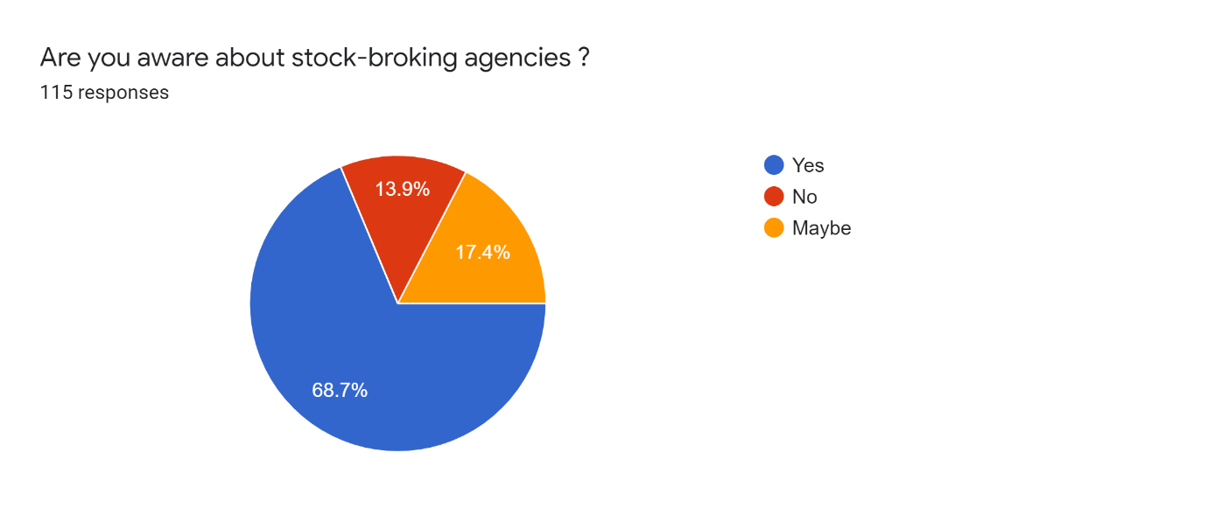

Stock Broking Professionals are known as Stock Broker. A stock broker act as an agent who makes stock trades on behalf of their investors. They are also called as a securities sales agent or securities and commodities sales agent.

A stockbroker (also known as a registered representative, investment adviser or simply, broker) is a professional individual who executes buy and sell orders on behalf of clients for stocks and other securities in a listed market or over the counter, usually for a fee or commission.

As per above survey, 68.7% of people aware about stock broking agencies. 13.9% of people not aware about stock broking agencies. 17.4% of people maybe know about stock broking agencies, So the result is majority of people is aware about stock broking agencies.

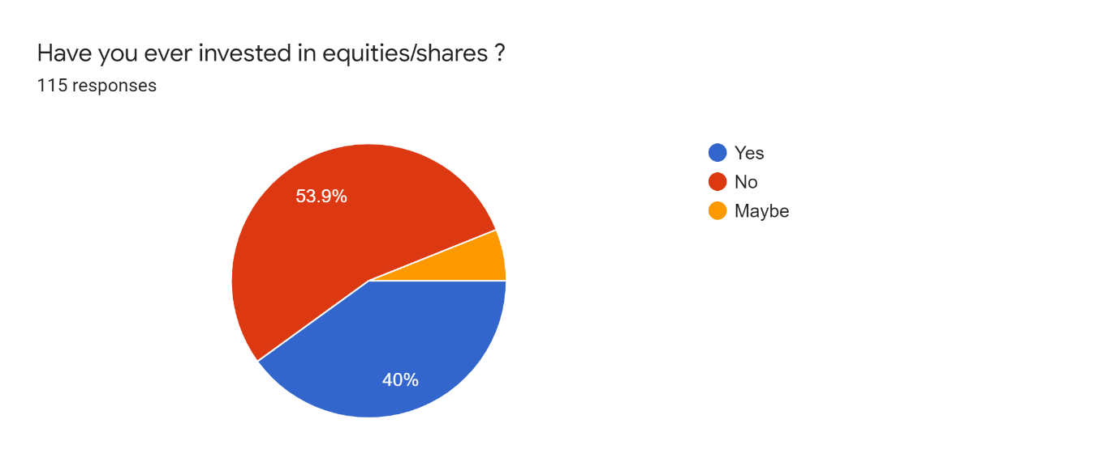

An equity investment is money that is invested in a company by purchasing shares of that company in the stock market. These shares are typically traded on a stock exchange.

Equity**when it comes to the market, equity is just a fancy term for**shares, ***as in* shares of stock.**In other words, when companies offer equities, they’re offering you a share in the business – part ownership in a sense. You might also get or earn equity as a new hire.

As per above survey, 40% of people invest in equities/shares. 53.9% of people not invest in equities/shares. 6.1% of people maybe invest equities/shares, So the result is majority of people not invested in equities/shares.

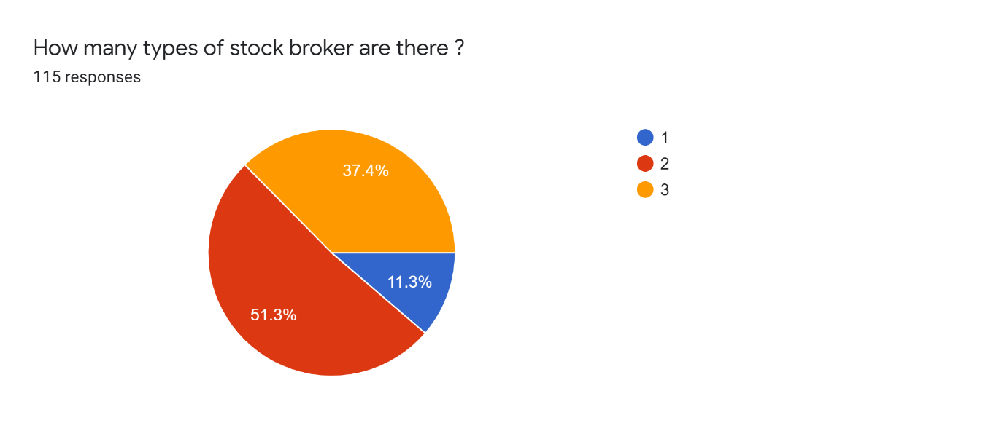

A stock investor or trader can look into three main types of brokers: full-service brokers, discount brokers, and robo-advisers.While they all act as a facilitator between you and another party, they operate differently from each other.

A full-service broker offers a range of add-ons in addition to trading at stock exchanges. This includes research reports, advisory and a relationship manager apart from helping you buy and sell shares.

A discount broker is a stockbroker who carries out buy and sell orders with little or no commissions. Discount brokers do not provide the investment advice or guidance provided by a full-service broker. Discount online brokers compose a large section of the fintech industry.

Robo-advisors are digital platforms that provide automated, algorithm-driven financial planning services with little to no human supervision. The best robo-advisors offer easy account setup, robust goal planning, account services, and portfolio management.

As per above survey, 11.3% of people says 1 type of stock broker there. 51.3% of people says 2 types of brokers are there. 37.4% of people says 3 types of stock brokers are there, So the result is 3 types of stock brokers are there.

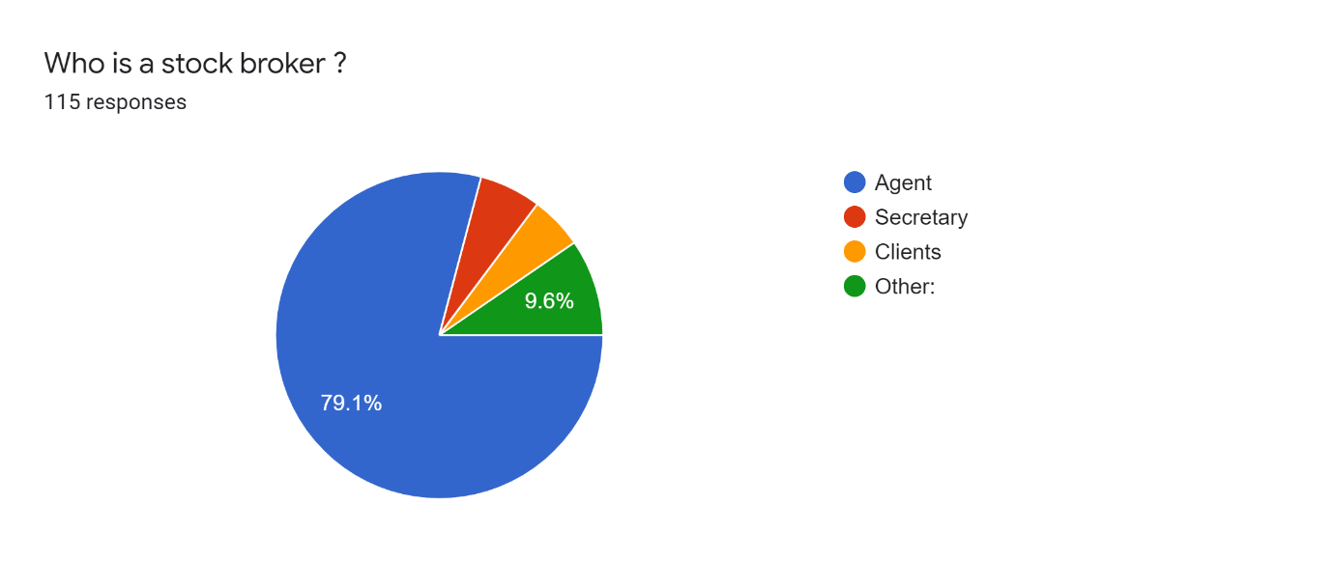

An agent, in legal terminology, is a person who has been legally empowered to act on behalf of another person or an entity. An agent may be employed to represent a client in negotiations and other dealings with third parties. The agent may be given decision-making authority.

Broker as defined in the Concise Law Dictionary means a middleman or agent who, for a commission on the value of the transmission, negotiates for others the purchase or sale of stocks, bonds, commodities or property of any kind, or who attends to the doing of something for another.

As per above survey, 79.1% of people stock broker is an agent. 6.1% of people says stock broker is a secretary. 5.2% of people says stock broker is a client and 9.6% of people says stock broker is a other person, So the result is stock brokers is an agent.

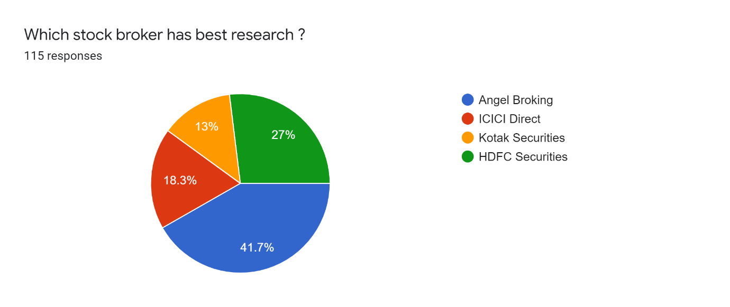

Full Service brokers. Kotak Securities is having overall lower rating compare to Angel Broking. Kotak Securities is rated only 4 out of 5 where Angel Broking is rated 4.5 out of 5.

The HDFC Securities trading account has a unique 3-in-1 feature that integrates your HDFC Securities trading account with your existing HDFC bank savings account and existing Demat account.

As per above survey, 41.7% of people says Angel Broking has best research. 18.3% of people says Angel Broking has best research. 13% of people says Angel Broking has best research. 27% of people says Angel Broking has best research, So the result is Angel Broking, ICICI Direct, Kotak Securities, HDFC Securities is best research.

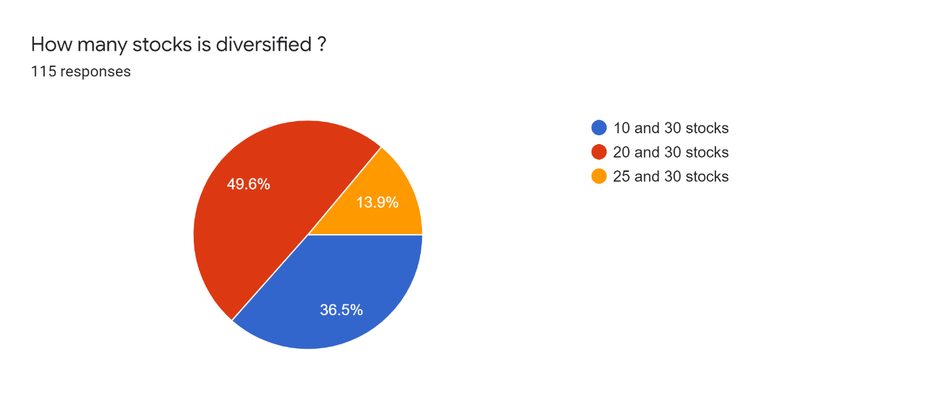

The average diversified portfolio holds between 20 and 30 stocks. Diversifying your portfolio in the stock market is an investing best practice because it decreases non-systemic, or company-specific, risk by ensuring that no single company has too much influence over the value of your holdings.

As per above survey, 36.5% of people says 10 and 30 stocks is diversified. 49.6% of people says 20 and 30 stocks is diversified. 13.9% of people says 25 and 30 stocks is diversified, So the result is 20 and 30 stocks is diversified.

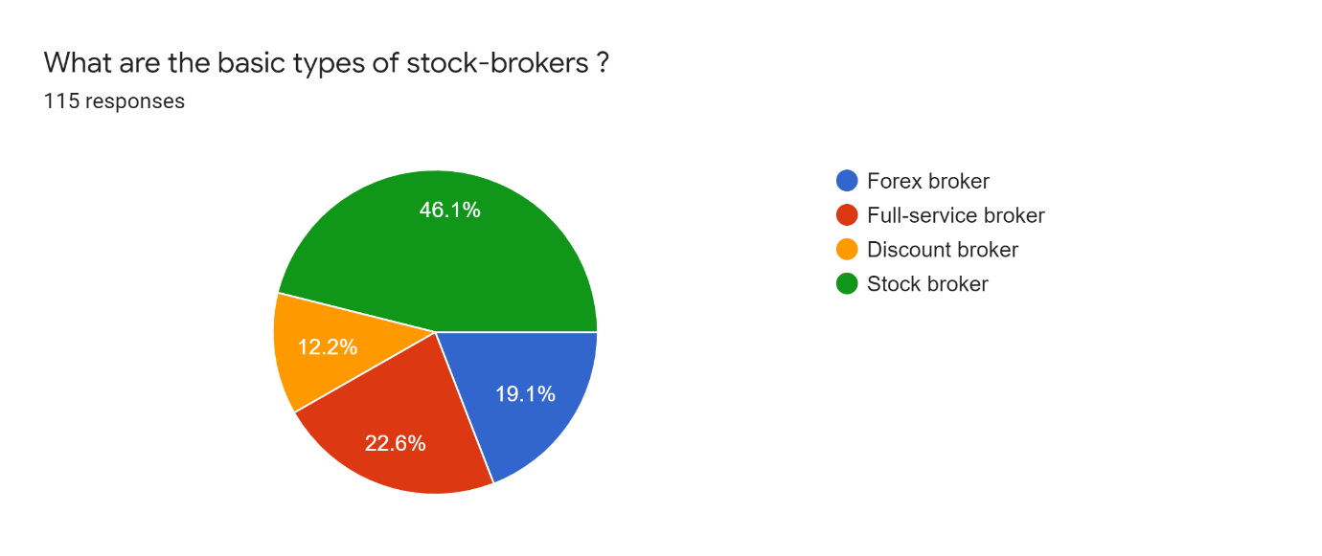

A foreign exchange broker, also known as an FX broker or a forex broker, buys and sells currencies on behalf of clients while charging a commission for the service

A full-service broker offers a range of add-ons in addition to trading at stock exchanges.

A discount broker is a stockbroker who carries out buy and sell orders at reduced commission rates compared to a full-service broker.

A stockbroker is a financial professional who executes orders in the market on behalf of clients.

As per above survey, 19.1% of people says forex broker, 22.6% of people says full-service brokers, 12.2% of people says discount brokers, 46.1% of people says stock brokers the all are basic types of stock brokers, So the result is all four basic types of stock brokers.

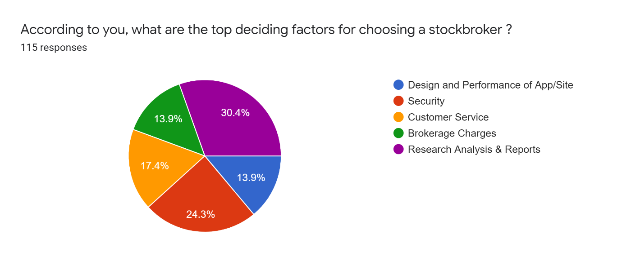

Design Performance is a gradient of decisions and philosophies that allow a company to rely on the attributes of strong design thinking and the principles of a human-centered design strategy.

The term "security" refers to a [fungible](https://www.investopedia.com/terms/f/fungibility.asp), negotiable [financial instrument](https://www.investopedia.com/terms/f/financialinstrument.asp) that holds some type of monetary value.

The minimum brokerage charge by the full-service brokers is the minimum commission they charge for trading with them.

A research report is a document prepared by an analyst or strategist who is a part of the investment research team in a stock brokerage or investment bank.

As per above survey, 13.9% of people says design and performance of app/site are the top factors for choosing a stockbroker. 24.3% of people says security are the top factors for choosing a stockbroker. 17.4% of people says customer service are the top factors for choosing a stockbroker. 13.9% of people says brokerage charges are the top factors for choosing a stockbroker. 30.4% of people says research analysis and reports are the top factors for choosing a stockbroker, So the result is all are the top factors for choosing a stockbroker.

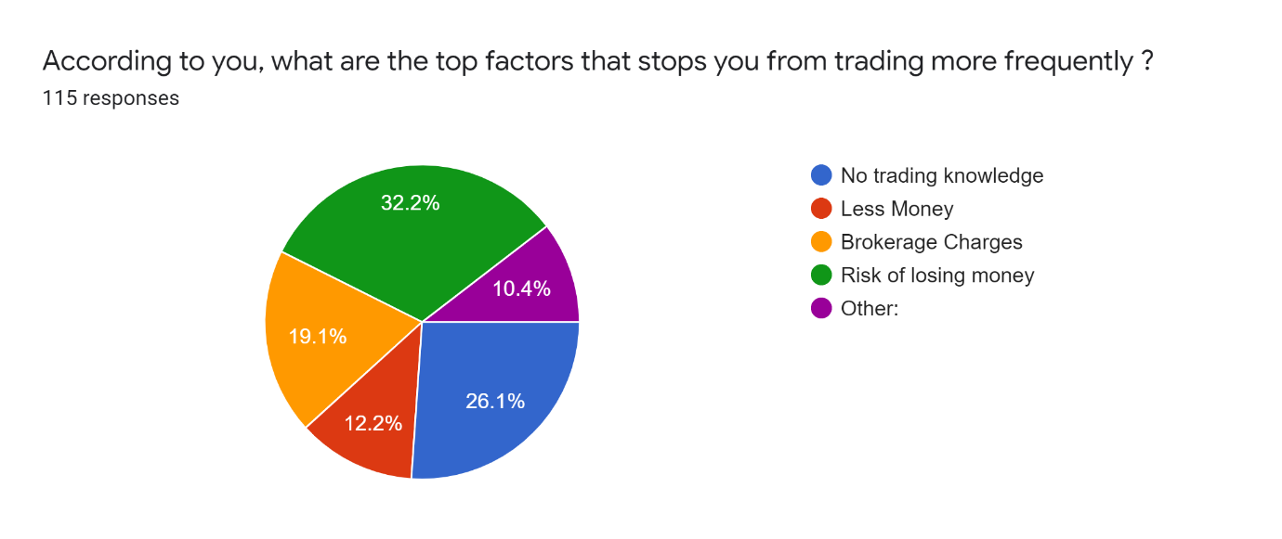

There are a number of factors that can have an impact on an investor's [entry](https://www.investopedia.com/terms/e/entry-point.asp) (buy) into or [exit](https://www.investopedia.com/terms/e/exit-point.asp) (sell) out of a given stock or [sector](https://www.investopedia.com/terms/s/sector.asp). Depending on the investor and their goals and investing time frame, the importance of [timing](https://www.investopedia.com/terms/m/markettiming.asp) the entry will differ.

That said, all investors should be aware of some of the more common market-moving influences that can affect a stock's price.

As per above survey, 26.1% of people says no trading knowledge are the top factors that stops you from trading more frequently. 12.2% of people says less money are the top factors that stops you from trading more frequently. 19.1% of people says brokerage charges are the top factors that stops you from trading more frequently. 32.2% of people says risk of losing money are the top factors that stops you from trading more frequently. 10.4% of people says other factors are the top factors that stops you from trading more frequently, So the result is are all the top factors that stops you from trading more frequently.

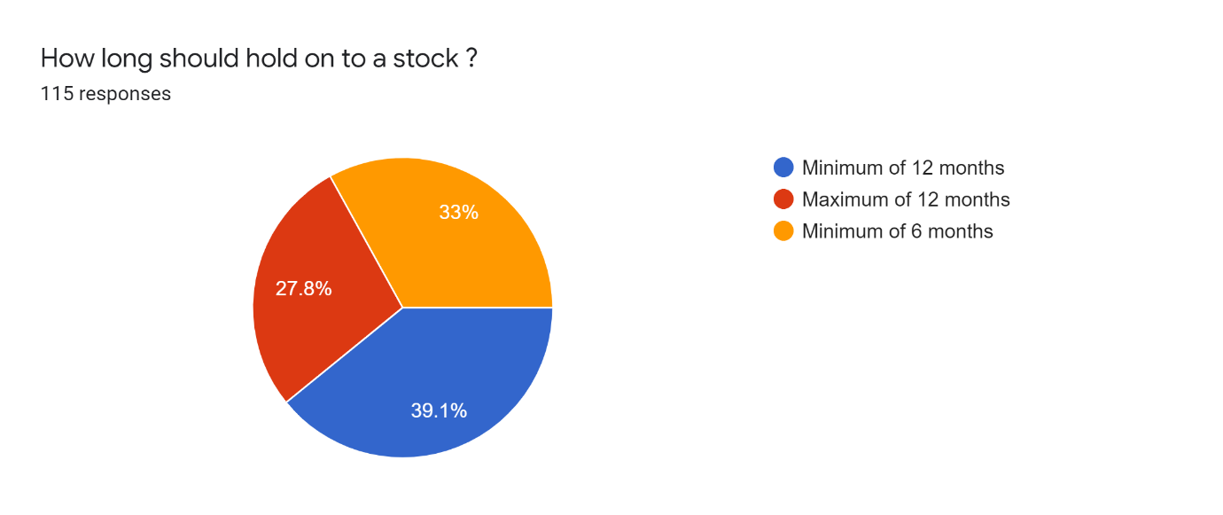

As with any asset, you must hold a stock for a minimum of 12 months in order for it to be considered a long-term investment. Anything under that is deemed a short-term holding.

As per above survey, 39.1% of people says minimum of 12 months should hold on to a stock. 27.8% of people says maximum of 12 months should hold on to a stock. 33% of people says minimum of 6 months should hold on to a stock, So the result is minimum of 12 months should hold on to a stock.

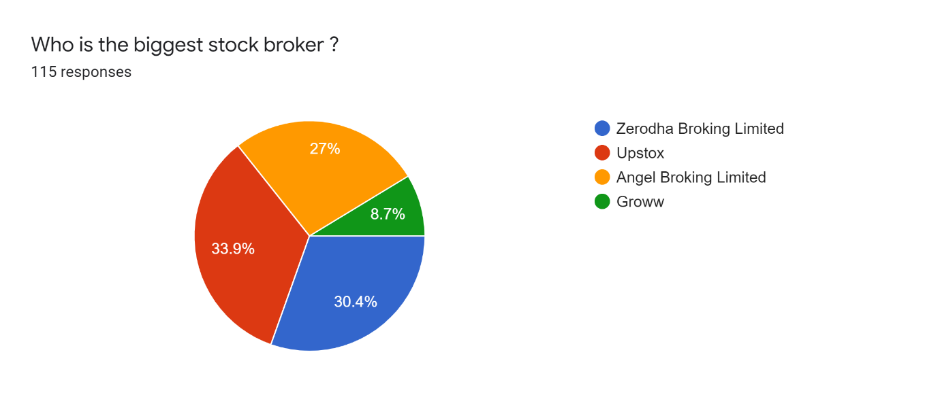

In terms of valuation or market cap, Zerodha Broking Limited is the largest stockbroker in India. Other stockbrokers like Groww and Upstox are also more valued and bigger in terms of valuation, though Angel Broking Limited is a bootstrapped company.

Zerodha is one of the most best brokers in India. The broker is one of the first trading companies to adapt discounted brokerage services. The trader has headquarters in Bangalore and owns 15% of the entire client base of India.

As per above survey, 30.4% of people says zerodha broking limited is the biggest stockbroker. 33.9% of people says upstox is the biggest stockbroker. 27% of people says angel broking limited is the biggest stock broker. 8.7% of people says groww is the biggest stockbroker, So the result is zerodha broking limited is the biggest stockbroker.

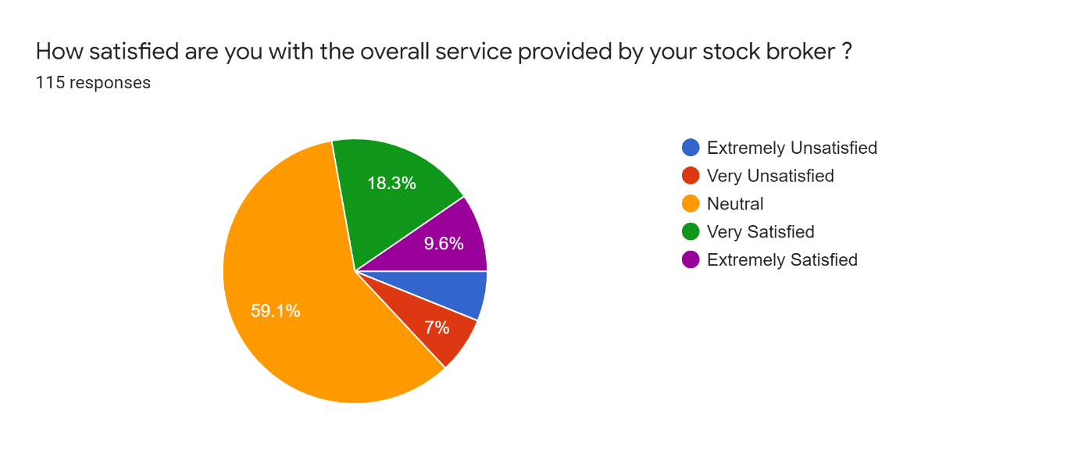

These brokers can not only help you with your investment needs but also provide assistance with estate planning, tax advice, retirement planning, budgeting, and any other type of financial advice—hence the term “full service.” They can help you manage all of your financial needs now and long into the future.

As per above survey, 6.1% of people says extremely unsatisfied with the overall service provided by their stockbroker. 7% of people says very unsatisfied with the overall service provided by their stockbroker. 59.1% of people says neutral with the overall service provided by their stockbroker. 18.3% of people says very satisfied with the overall service provided by their stockbroker. 9.6% of people says extremely satisfied with the overall service provided by their stockbroker. So as per result majority of people are says neutral service provide by their stockbroker.

**CONCLUSION**

Most of the customers are not associated from a long period with their stock broking firms and these customers are some times satisfied with their Stock Broking Firm. The reasons for association with this Stock Broking Firm are Brokerage, Trading Tips, Faith, Individual Attention, Brand Name and Accessibility, but Individual Attention gets maximum weightage. So if the customer is associated with a particular firm that means the reason behind this, is one of the above reasons. There are service quality gaps between the expectations and perceptions of the customers of stock broking firm which can be discuss with the help of different dimensions of service quality models like tangibility, reliability, responsiveness, assurance and empathy. There is a very less service quality gap regarding the tangibility factor because the customers’ expectations are not much higher than the perceptions. Customer gives importance to the reliability factor and the expectations of customers are much higher than the perceptions. If we discuss about the responsiveness than we also find out the deep service quality gap. Assurance is the most important dimension of the service quality and the customers have higher expectations regarding this and it creates a huge service quality gap. The expectations regarding the empathy are also not to much higher as compared to other dimensions, so the service quality gap is less as compared to other dimensions like reliability and assurance.

The study gives directions to all investment advisory firms and stock broking organizations to understand the behavior of retail equity investors.

• This study would be more useful for stock brokers to understand the behavior and expectations of their clients.

• The study will also be helpful for the first time investors in the equity market to understand the working of the brokers and make safe investments.

**SUGGESTION**

1. Stock broking firms have to focus on the different reasons for which customers are associated with stock broking firms and try to provide these facilities like less brokerage than competitors, gives trading tips and individual attention. So that customers will associate with the stock broking firms for longer period.

2. There is no need to focus on modern looking equipment, visually appealing physical facilities and neat appearance of employees because the customers of stock broking firms are not giving to much importance to these things.

3. Stock broking firms should fulfill their promises to do something by a certain time. So that the customers feel happy from the service delivered by the stock broking firms.

4. Stock broking firms should have show the sincere interest in solving the problem of customers, so that they feel satisfied from the service delivered by stock broking firm.

5. Stock broking firms should perform the service right the first time and the service at the time they promise to do so and should also try to insist on error free records. It will help in increasing the reliability.

6. The employees in the stock broking firms should tell the customers exactly when the services will be performed and also try to give the prompt service to the customers and also the stock broking firms are quickly respond to customer’s request. It will help tin increasing the responsiveness.

7. The employees in stock broking firm should instils confidence in customers and consistently courteous with customers, so that customers feel safe in transactions with the stock broking firm.

8. The employees of stock broking firm should have that much knowledge to answer the questions of customers and this gives a birth to a very large service quality gap.

9. Stock broking firm should give the individual attention given to the customers and operating hours of the stock broking firms should convenient to the customers as per their expectations. Stock broking firms should have customer’s best interests at heart and should understand the specific needs of customers.

**BIBLIOGRAPHY**

1. <http://hdl.handle.net/10603/10928>
2. <https://www.researchgate.net/publication/333971213>
3. <https://www.investopedia.com/investing/brokerage-functions-underwriting-and-agency-roles/>
4. <https://www.investopedia.com/terms/s/stockbroker.asp>
5. <https://swastika.co.in/blog/stock-broker-importance-overview-types-and-responsibilities/>
6. <https://www.adityabirlacapital.com/abc-of-money/what-is-the-importance-of-brokers-in-the-stock-market>
7. <https://en.wikipedia.org/wiki/Stockbroker>
8. <https://en.wikipedia.org/wiki/Stockbroker>

**APPENDIX**

Are you aware about stock-broking agencies ? *

* Yes
* No
* Maybe

Have you ever invested in equities/shares ? *

* Yes
* No
* Maybe

How many types of stock broker are there ? *

* 1
* 2
* 3

Who is a stock broker ? *

* Agent
* Secretary
* Clients
* Other:

Which stock broker has best research ? *

* Angel Broking
* ICICI Direct
* Kotak Securities
* HDFC Securities

How many stocks is diversified ? *

* 10 and 30 stocks
* 20 and 30 stocks
* 25 and 30 stocks

What are the basic types of stock-brokers ? *

* Forex broker
* Full-service broker
* Discount broker
* Stock broker

According to you, what are the top deciding factors for choosing a stockbroker ? *

* Design and Performance of App/Site
* Security
* Customer Service
* Brokerage Charges
* Research Analysis & Reports

According to you, what are the top factors that stops you from trading more frequently ? *

* No trading knowledge
* Less Money
* Brokerage Charges
* Risk of losing money
* Other:

How long should hold on to a stock ? *

* Minimum of 12 months
* Maximum of 12 months
* Minimum of 6 months

Who is the biggest stock broker ? *

* Zerodha Broking Limited
* Upstox
* Angel Broking Limited
* Groww

How satisfied are you with the overall service provided by your stock broker ? *

* Extremely Unsatisfied
* Very Unsatisfied
* Neutral
* Very Satisfied
* Extremely Satisfied